**Predictive genetic testing and motor neuron disease**

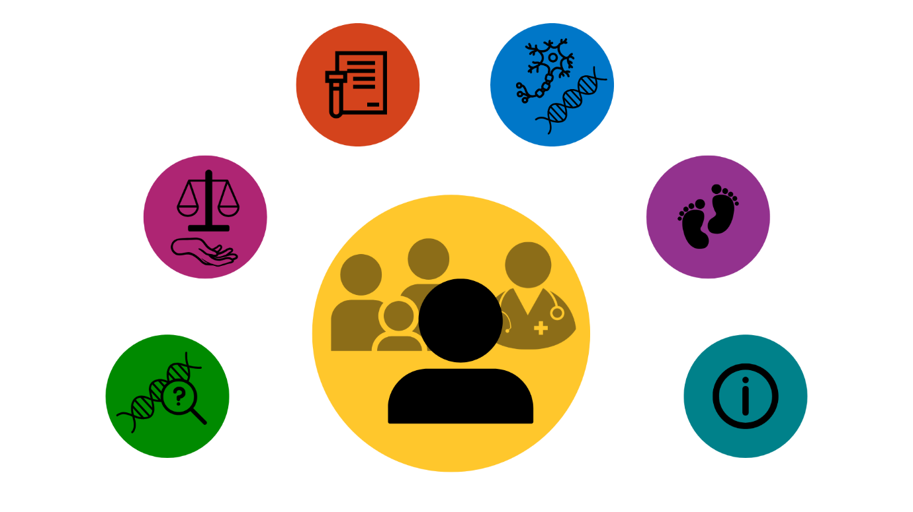

**A decision ai****d**

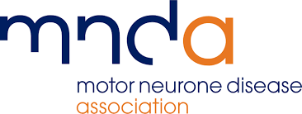

**About this decision aid**

This decision aid is designed to help you think about your options around predictive genetic testing for motor neuron disease (MND). Predictive genetic testing is available where a gene change linked to MND has been found in a close family member. In some countries, MND is known as Amyotrophic Lateral Sclerosis (ALS).

Making a decision about predictive genetic testing is personal to you, and your life. Your decision may have consequences for you, and your family. Your views about predictive genetic testing may change over time.

This decision aid has information about two testing options:

* **Not have predictive genetic testing (at this time)**
* **Have predictive genetic testing**

This decision aid has prompts to help you think about what is important to you. These prompts can help you talk about your options with your family, and health professionals.

The Predictive genetic testing and motor neuron disease decision aid was developed by researchers at the Universities of Sheffield and Leeds, families living with MND, and health professionals. Our research was funded by the Motor Neurone Disease Association.



**Disclaimer:** Every effort has been made to provide accurate information. However, facts about genetics in MND and genetic testing can change over time. Check with your local healthcare team about the facts you are using when making decisions.

This resource was last updated in June 2025.

**Contents**

**Section A:** Predictive genetic testing decisions and inherited motor neuron disease……..3-7

**Section B:** Making my decision about predictive genetic testing ………………………......8-12

**Section C:** The MND predictive genetic testing process………………………………......13-15

**Section D:** MND and genetics……………..………………………………………………….16-20

**Section E:** Options for having a family in MND…………………………………………......21-23

**Section F:** Further information - glossary, resources, references and project details…..24-31

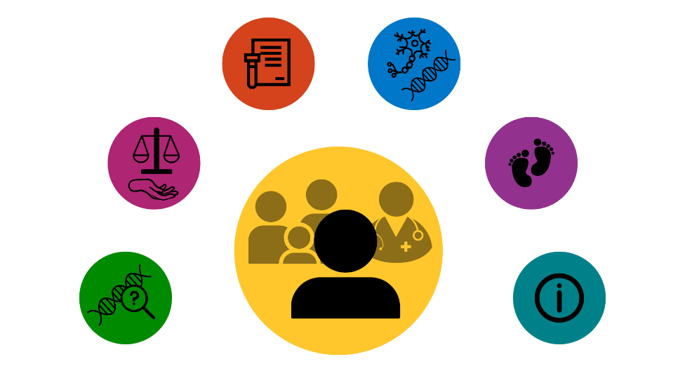

In this decision aid you will find:

* **Written information** to give you facts when making this decision.
* **Decision maps** tolay out the testing options.
* **Tables** to give a summary about each option and the consequences.
* **Diagrams** to show steps and processes around genetic testing.
* **Prompts and writing spaces** to give you space to jot down your thoughts and questions.

People use this decision aid in different ways. You may like to read it from beginning to end, or dip in and out of sections when you feel ready. You might find it helpful to talk through your decision with your family, friends and health professionals. Use this decision aid in the way that suits you best.

This decision aid includes facts scientists and health professionals use to guide care. In this decision aid, we use numbers in brackets to link our facts with scientific papers and other references, for example [6] or [13]. You can find the list of references in Section F. Section F also includes links to other resources that you or your family members may find useful.

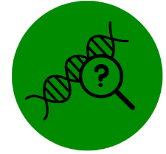**Section A:** **Predictive genetic testing decisions and inherited motor neuron disease**

This section is designed to help you think about your options around predictive genetic testing (also known as presymptomatic testing). To make a decision about predictive genetic testing, you must:

* Have a close family member with a gene change linked to MND (people having predictive testing are tested for the gene change found in their family)
* Not have symptoms of MND
* Be 18 years old or older [1]

The options for people thinking about predictive genetic testing are:

**Not have predictive genetic testing (at this time):** *Not having* predictive genetic testing means you will not find out if you have the gene change linked to MND, or not. People not having testing do not want to find out this information at this stage of their life.

**Have predictive genetic testing:** *Deciding to have* predictive genetic testing means you will find out whether or not you have the gene change linked to MND. There are two possible results:

* Negative - means you do not have the gene change linked to MND.
* Positive - means you have the gene change linked to MND. People with a gene change have a higher chance of developing MND in their lifetime. Not everyone with a gene change will get MND [2]. Predictive genetic testing does not provide information about how or when symptoms may start.

If you are interested in predictive genetic testing, you can ask your GP to be referred to a clinical genetics department at a hospital. You will go through a process called genetic counselling with a genetics doctor or a genetic counsellor, to help you to think through your options and the consequences [3-5].

People can see a genetic counsellor even if they do not plan to have predictive genetic testing at that time, to help them understand MND in their family and related issues such as sharing information with relatives or having children. This includes younger people under 18.

It is up to each person in a family to make their own decision about predictive genetic testing, at a time that is right for them.

**Decision map: predictive genetic testing decisions**

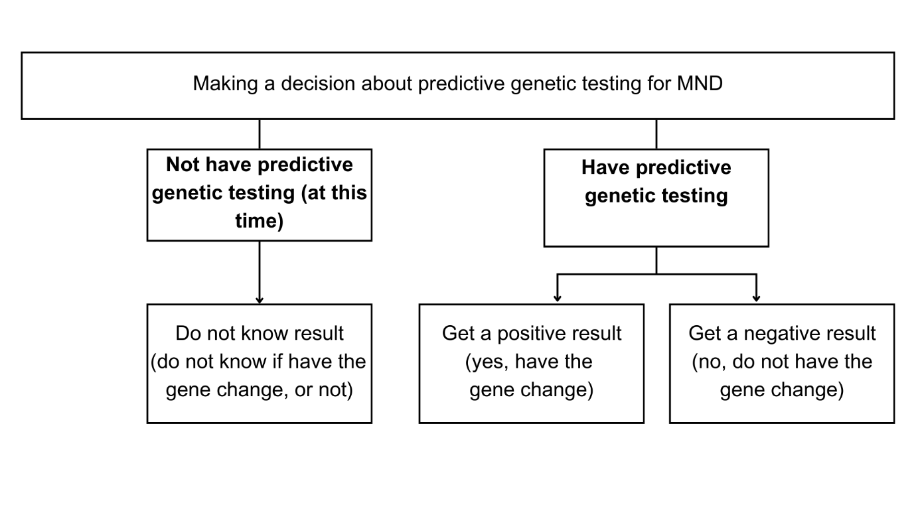

**Having a gene change linked to MND in family**

People are diagnosed with MND by specialist doctors called neurologists, based on their symptoms [6]. People with MND may be able to have a genetic test to look for a gene change linked to their disease [7]. In England, all people with MND can have genetic testing [8, 9].

The most common gene changes linked to inherited MND are: *SOD1*, *TARDBP*, *FUS*, and *C9orf72.*  Some gene changes linked to MND are also linked to other neurological health problems, including frontotemporal dementia (FTD) [10, 11]. People with these gene changes may get MND, FTD or both diseases. Some people will not get either disease. Section D goes over this information in more detail.

When MND is passed down in families, it is sometimes called genetic, familial, or inherited MND [5]. About 10-20% of people with MND have an inherited form of MND*.* Most people with inherited MND have a 50% (1 in 2) chance of passing the gene change to each of their children [10, 11].

Finding out about inherited MND in the family can raise many emotions and questions for family members. Some people want to know about their options around predictive genetic testing. Some people do not feel it is important to know about predictive genetic testing, or do not feel ready to find out more at this time [12-16].

The rest of this decision aid is designed for people who wish to think about their predictive genetic testing decision.

**Making a decision to know, or not know, about having a gene change linked to MND**

When making a decision about predictive genetic testing, you might think about what difference having testing, or not having testing, could make to your life now, and to your future plans [13, 16]. Thinking through some of the following issues can help you make a decision that is right for you:

**Timing:** Some people think about what else is happening in their lives when making a decision about having predictive genetic testing or not. For example, getting married could be a possible reason for both having testing, or not having testing.

**Wellbeing and coping**: People sometimes think about if they would cope better either knowing, or not knowing, their predictive test result. You might think about how you would feel if you got a negative result, or a positive result. Getting a positive result means people continue living with uncertainty, as they do not know if they will get MND or not, or how and when symptoms may start.

**Health and illness:** Having or not having predictive genetic testing does not affect your health. At this time, there are no treatments that have been proven to prevent MND in people with a gene change. If you are worried about symptoms of MND, you can ask your GP to see a neurologist. You can see a neurologist about possible symptoms whether or not you have had predictive testing.

**Family:** Having predictive genetic testing may give information about the chance other relatives, including children, could get MND in the future. You may want to think about what your decision means for your family members, including children.

You may think about talking to family members about your decision. Some people feel it is important to have these conversations. Others find these conversations difficult. Family members may have similar or different views about testing.

You may want to think about how you would share your result with family members. Some people in the family may want this information. Others may prefer not to know. Learning about predictive testing decisions, and results, of other family members can raise many emotions.

People can speak with genetic counsellors about what it might mean if one person in the family wants a test, and another person does not. For example, if a person knows their grandparent has an inherited form of MND caused by a gene change and wishes to have predictive testing, but their parent does not wish to have predictive testing. If the person got a positive result for the gene change linked to MND, it would mean their parent had the same gene change.

**Family planning:** You might think about plans for having children when making your decision. Some people decide to have a family without having predictive genetic testing. Others decide to have predictive genetic testing to help them make reproductive decisions. People who wish to have a child without taking the chance of passing on the gene change may think about reproductive genetic testing (Section E). Your healthcare team can give advice on what options are available based on your circumstances.

**Research:** Taking part in research is a personal decision. You can take part in some studies whether or not you have predictive genetic testing. Some studies only include people who know they have a gene change linked to MND. This includes clinical trials looking to see if genetically targeted treatments can stop or delay people with a gene change from getting MND. Your healthcare does not depend on whether or not you take part in a study. Links to information about research and how to take part are available in Section F.

**Insurance:** In the UK, companies are not told if a person has had predictive genetic testing or not. It is important to be honest about the family history of different health conditions with insurers, but you do not have to share information about predictive genetic testing. Other countries may have different laws. You may wish to find information on how predictive genetic testing could impact your insurance before having a test. Links to more information are available in Section F.

**Testing Costs** – In the UK, genetic counselling and predictive genetic testing are paid for by the NHS. There may be costs for predictive genetic testing in other countries.

**Thinking about what matters most to you**

You might find it helpful to think through some of the following questions when making your decision:



* How important is it for me to know whether or not I have a gene change linked to MND?
* How would I cope with knowing I have, or do not have, a gene change linked to MND?
* How important is it for me to know if I have a gene change when speaking with relatives?
* How important is it for me to know if I have a gene change when planning a family?
* How much do I want to find out if I could take part in research studies testing genetically targeted treatments?

***Use this space to jot down your thoughts or questions. You can use these notes when talking with your family and healthcare team.***



**Section B:** **Making my decision about predictive genetic testing**

This section helps you think about which predictive genetic testing option is best for you, in the short and longer term.

People have different views about predictive genetic testing options, and different reasons for making their testing choice [12, 13, 15, 16]. People make trade-offs about what suits them best, for example:

People not having testing do not want to find out the results of a predictive test for MND at this stage of their life. They are more comfortable with not knowing if they have a gene change linked to MND, than knowing. People may change their mind later in their lives.

People having testing want to know if they have a higher chance of getting MND, or not. They have more reasons to find out their results, than reasons for not finding out, at this stage in their lives.

Some people feel unsure about what is right for them, or they have mixed views. The rest of this section helps you think about what is right for you at this time.

The decision map shows options open to you now, and if your views change over time.

**Decision Map: Predictive genetic testing decisions and options for changing the decision**

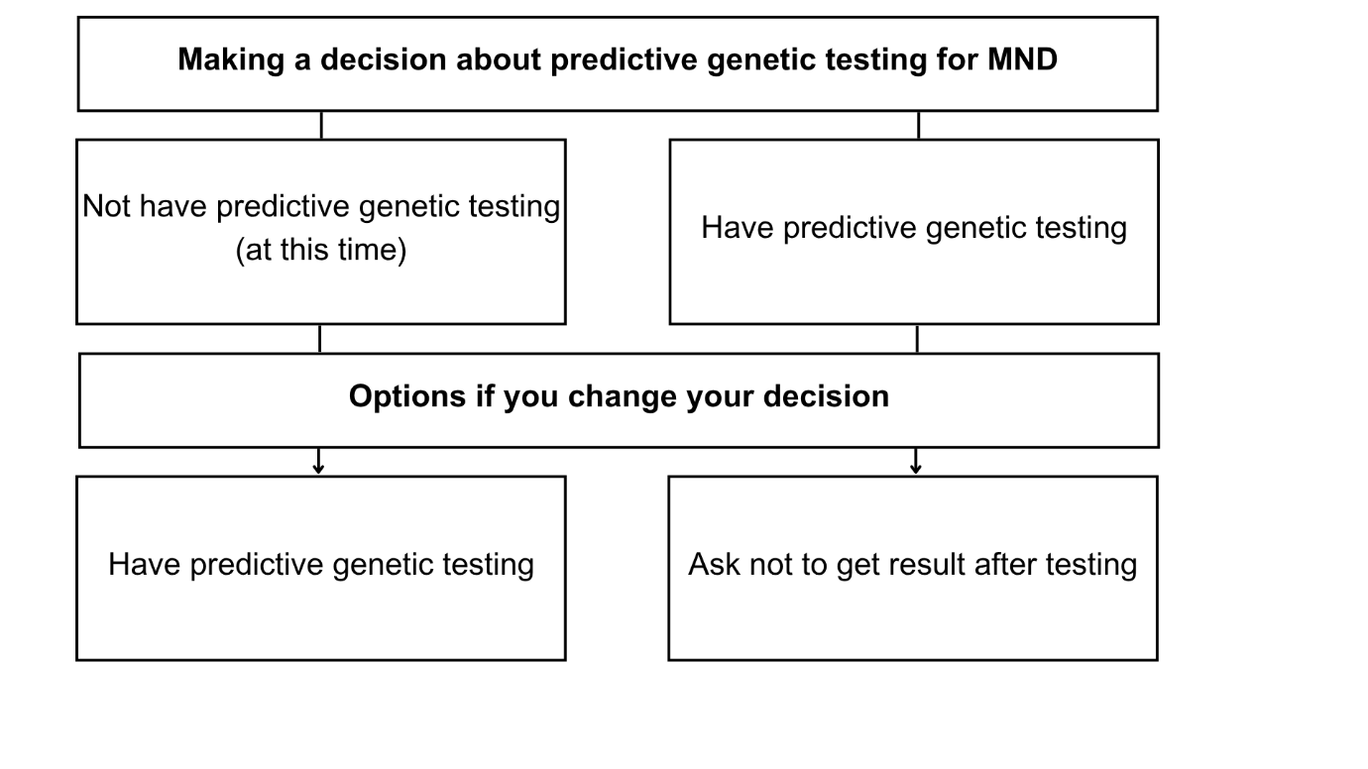

**Summary table of information about the two predictive genetic testing options**

|  |  |  |
| --- | --- | --- |
|  | **Not have predictive genetic testing (at this time)** | **Have predictive genetic testing** |
| **Testing process** | You will have the chance to talk about your options in genetic counselling.  You will not sign a consent form or give a blood sample. | You will have genetic counselling, to talk about your options. You may have several appointments.  You will sign a consent form and give a blood sample. You will get your results in a follow-up consultation. |
| **Knowledge about gene change** | You will not know if you have a gene change linked to MND or not. | You will find out if you have the gene change linked to MND (a positive result) or not (a negative result). A positive result will not tell you if you will get MND or not. It will not tell you how or when symptoms may start. |
| **Impact on family** | Not having predictive genetic testing means you will not know the chance of your children having the same gene change. Family members may have similar or different views about testing. | Your test result may give information about the chance other relatives, including children, could have the gene change linked to MND. Family members may have similar or different views about testing. |
| **Connected decisions** | You may be able to think about reproductive genetic testing.  You may think about taking part in research. You will not be able to take part in studies which only include people who know they have a particular gene change linked to MND. | You may be able to think about reproductive genetic testing.  You may think about taking part in research. If you get a positive predictive test result, you may be able to join studies for people with your particular gene change (if available). |

**Not have predictive genetic testing (at this time): my reasons for and against this option**

Not having predictive genetic testing means you will not find out if you have the gene change linked to MND, or not.

***You might find it useful to think about or jot down what you like or do not like about this option. You can use this to talk with your family, or health professionals [17, 18].***

|  |  |
| --- | --- |
| ***Reasons I like* the ‘not have predictive testing’ option**  [how important is each reason for you, * = slightly important, ** = quite important, *** = very important] | **Importance (*/**/***)** |
|  |  |
|  |  |
|  |  |
| ***Reasons I do not like* the ‘not have predictive testing’ option**  [how important is each reason for you, * = slightly important, ** = quite important, *** = very important] | **Importance (*/**/***)** |
|  |  |
|  |  |
|  |  |

**Have predictive genetic testing: my reasons for and against this option**

Deciding to have predictive genetic testing means you will get a test result that tells you if you have the gene change linked to MND (positive result) or not (negative result).

***You might find it useful to think about or jot down what you like or do not like about this option. You can use this to talk with your family, or health professionals.***

|  |  |
| --- | --- |
| ***Reasons I like* the ‘have predictive testing’ option**  [how important is each reason for you, * = slightly important, ** = quite important, *** = very important] | **Importance (*/**/***)** |
|  |  |
|  |  |
|  |  |
| ***Reasons I do not like* the ‘have predictive testing’ option**  [how important is each reason for you, * = slightly important, ** = quite important, *** = very important] | **Importance (*/**/***)** |
|  |  |
|  |  |
|  |  |



**Deciding which predictive genetic testing option is right for you**

Given what you have read so far, use the table below to rate how likely you are to choose each of the predictive genetic testing options.

**How likely am I to have these testing options (mark an answer for each option):**

|  |  |  |  |  |  |
| --- | --- | --- | --- | --- | --- |
|  | **No**  **Definitely Not** | **No**  **Maybe** | **Not**  **Sure** | **Yes**  **Maybe** | **Yes**  **Definitely** |
| **Not have predictive genetic testing (at this time)** |  |  |  |  |  |
| **Have predictive genetic testing** |  |  |  |  |  |

Information about predictive genetic testing in MND is complicated. Use the questions below to see if you need to ask for more information or support before making this decision [19].

**Mark ‘yes’ or ‘no’ for each option:**

|  |  |  |
| --- | --- | --- |
|  | **Yes** | **No** |
| Do you feel sure about the best choice for you? |  |  |
| Do you know the benefits and risks of each option? |  |  |
| Are you clear about which benefits and risks matter most to you? |  |  |
| Do you have enough support and advice to make a choice? |  |  |

***Use this space to jot down your thoughts or questions. You can use these notes*** ***when talking with your family and healthcare team.***



**Section C: The MND predictive genetic testing process**

This section describes the genetic counselling and predictive genetic testing process in the UK [3]. Your healthcare team can share information about the process in your local area and timings involved.

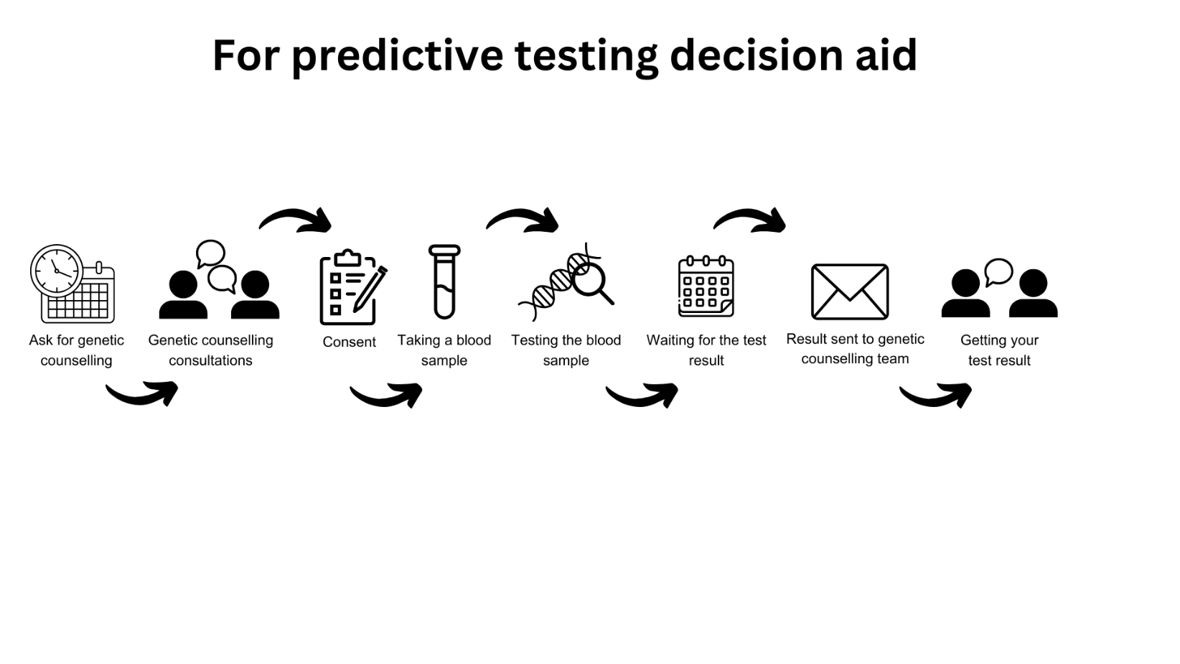

|  |  |
| --- | --- |
| An image showing asking to see a genetic counsellor | **Ask for genetic counselling:** You can ask your GP (general practitioner) to refer you to a clinical genetics service for genetic counselling. This will involve speaking with a genetic counsellor or a clinical geneticist. Genetic counselling and predictive genetic testing are offered free of charge on the NHS. It can take some time get an appointment to the service. |
| An image showing the genetic testing consultation | **Genetic counselling consultations:** Genetic counselling takes place in at least two consultations over a few months. Some people may have more consultations over a longer period of time. The service wants people to be sure they make the best decision for them and feel sure about their decision.  In your consultations you will talk about topics including the chance of having a gene change linked to MND and what this could mean for your future. Your genetic counselling team want to understand your reasoning and find out what the decision means for you and your family. They want to help you be ready to cope with the test result.  You do not need to make a decision about predictive genetic testing in these consultations. You can take as long as you need to make this decision. Some people decide not to have a test at this point or at all. Some move onto the next step in the testing process. You can have a spouse, Section C logofamily member or friend in the consultations for support, and to ask questions.  The steps below describe what will happen if you choose to have predictive genetic testing. |
| An image showing consent | **Consent:** You will be asked togive written consent. This decision is yours to make, without pressure from other people. Your genetic counselling team will talk about how you will get the test result. |
| An image showing taking a blood sample | **Taking a blood sample:** A health professional will take a small sample of blood, usually from your inner arm using a needle. This is done in the same way as a normal blood test. You will feel a scratch when the need goes in. The blood will be collected in a small tube. |
| An image showing testing the blood sample | **Testing the blood sample:** Your blood sample will be sent to a laboratory where scientists carry out predictive genetic testing. It can take several weeks to several months for services to get predictive genetic test results back from the laboratory. |
| An image showing waiting for the test result | **Waiting for the test result:** People have many different emotions whilst waiting for their results. People’s lives and decisions can change in the time between sending off the blood sample and getting the result back. Some people are sure they want to know their test result. Others are unsure if they want to know their test result. You can let your genetic counselling team know if you want to wait to find out your test result, or not get it back at all. |
| An image showing the test result being sent to the healthcare team | **Result sent to genetic counselling team:** Your test result is sent to your genetic counselling team. |
| An image showing a person getting their result | **Getting your test result:** People usually have a consultation in person, but it may be on-line. Talking with the genetic counselling team about the test result can help you understand what the test result means for you and your family. You can have a spouse, family member or friend in the consultation for support, and to ask questions.  The predictive genetic testing process can be difficult, especially the time after being given results. Some people are offered follow-up support after their results, such as the chance to speak again with a genetic counsellor. There is no long-term support package available to everyone. Some people may need extra support. |

**Finding further information and support when making predictive genetic testing decisions and after results**

Genetic counselling services help you understand what predictive genetic testing means for you and your family [4]. People have different needs around predictive genetic testing [12, 13, 15]. Below are some organisations and services that can provide extra information and support.

* Psychological support: clinical psychologists, therapists and counsellors help people talk through issues important to their lives. These issues may be related to having MND in the family, having predictive testing, and finding ways of coping. You can ask your GP to refer you to psychological services. Some people choose to pay for these services privately.
* GPs: some people are supported closer to home by their general practice.
* MND Association: the MND Association provides information and support including written resources, and an online forum people can use to discuss predictive genetic testing and other topics.
* Neurologists: If you are worried about having symptoms of MND, neurologists can do tests to find out the cause of the symptoms. It is quite common for people to worry about possible symptoms, but it does not mean they have MND. You can ask your GP to refer you to a neurologist.

Section F has links to further information and support.

***Use this space to jot down your thoughts or questions. You can use these notes when talking with your family and healthcare team.***



***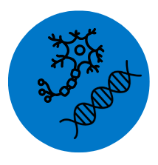*Section D: MND and genetics**

This section has brief information about MND symptoms, treatment and causes. See [www.mndassociation.org](http://www.mndassociation.org) for more information.

**Motor neuron disease**

Up to 5,000 adults are living with MND in the UK at any one time. Around 1 in 300 people (0.3% or 3 in 1000 people) develop MND in their lifetime. MND is diagnosed by neurologists. Neurologists are doctors who know about health problems linked to the brain and nervous system. MND is also called amyotrophic lateral sclerosis (ALS).

MND is a disease affecting the nerves (or neurons) in a person’s brain and spinal cord. Motor neurons are nerves that control how a person’s muscles move. MND damages these nerves, stopping them from controlling how the muscles move. People experience symptoms linked to the muscles that stop working, including muscle weakness, wasting and loss of movement; muscle tightness and cramps; problems with breathing and tiredness; difficulties with speech, swallowing and saliva. Some people’s thinking, behaviour and emotions change. Some people may get a form of dementia called frontotemporal dementia (FTD) [20].

***Managing MND***

Health and social care professionals help people manage their symptoms and keep as good a quality of life as possible. MND professionals include neurologists, physiotherapists, specialist nurses and occupational therapists. There is no cure for MND. MND is a life-shortening illness. Treatment and care plans help people with MND stay independent for as long as possible, and comfortable at the end of their lives [6, 21].

***Causes of MND***

MND is thought to be caused by a mix of factors linked to person’s environment, lifestyle, and genes. For about 80-90% of people with MND, the exact cause of their disease is not known. In about 10-20% of people with MND, their disease is caused by a gene change [10, 11, 20].

**Genetic or inherited forms of MND**

When MND is caused by a gene change, and passed down in families, this is known as inherited, familial or genetic MND [5]. When a disease is inherited, it means a gene change ******linked to the disease is passed down from a parent to their child. Each person has two sets of genes. One set of genes is passed down from each parent.

Scientists have found many gene changes linked to MND. They keep looking for more gene changes in their research. The most common gene changes in inherited MND are *C9orf72*, *SOD1*, *FUS* and *TARDBP*.

**Table summarising the most common gene changes in inherited MND** [10, 11]

|  |  |  |  |  |
| --- | --- | --- | --- | --- |
|  | ***SOD1*** | ***TARDBP*** | ***FUS*** | ***C9orf72*** |
| Year Found | 1993 | 2008 | 2009 | 2011 |
| Chance of the gene change passing from parent to child | 50% (1 in 2). There are rare gene changes where the chance is less. | 50% (1 in 2). There are rare gene changes where the chance is less. | 50% (1 in 2). There are rare gene changes where the chance is less. | 50% (1 in 2). |
| Chance of a person with the gene change getting MND | Not everyone with a gene change will get symptoms in their lifetime. | Not everyone with a gene change will get symptoms in their lifetime. | Not everyone with a gene change will get symptoms in their lifetime. | Not everyone with a gene change will get symptoms in their lifetime. |
| Age people develop symptoms | Adults of any age can develop symptoms. | Adults of any age can develop symptoms. | Adults of any age can develop symptoms. Some *FUS* gene changes can cause MND from teenage years. | Adults of any age can develop symptoms. |
| Link to other neurological health problems | SOD1 gene changes do not usually cause other health problems | *TARDBP* can cause FTD and other neurological symptoms. | *FUS* gene changes can cause FTD and other neurological symptoms. | *C9orf72* gene changes can cause FTD and other neurological and psychiatric symptoms. |
| Clinical trials and treatment | Tofersen can slow down the progress of the disease [22]. Ask a neurologist for further information. | No genetically targeted treatments have been found to work. See Section F for information on clinical trials. | No genetically targeted treatments have been found to work. See Section F for information on clinical trials. | No genetically targeted treatments have been found to work. See Section F for information on clinical trials. |

******People with MND experience the disease in different ways. Even when two relatives have the same gene change, they can get different symptoms, at different ages, and their disease progresses at different rates.

***MND and frontotemporal dementia (FTD)***

Certain gene changes linked to MND are also linked to other neurological health problems. For example, *C9orf72* is linked to MND and to frontotemporal dementia (FTD) [10, 11]. People with this gene change may get MND, FTD or both diseases. Some people may not get either disease. It is not possible to say which disease or symptoms people will get.

***How is MND passed down in families***

The chance of a gene change linked to MND being passed down from a parent to a child is usually 50% (1 in 2 chance). This is because most gene changes linked to MND are passed down in what is called a dominant inheritance pattern [10, 11]. Only one parent needs to have the gene change for their child to have a 50% chance of getting it.

 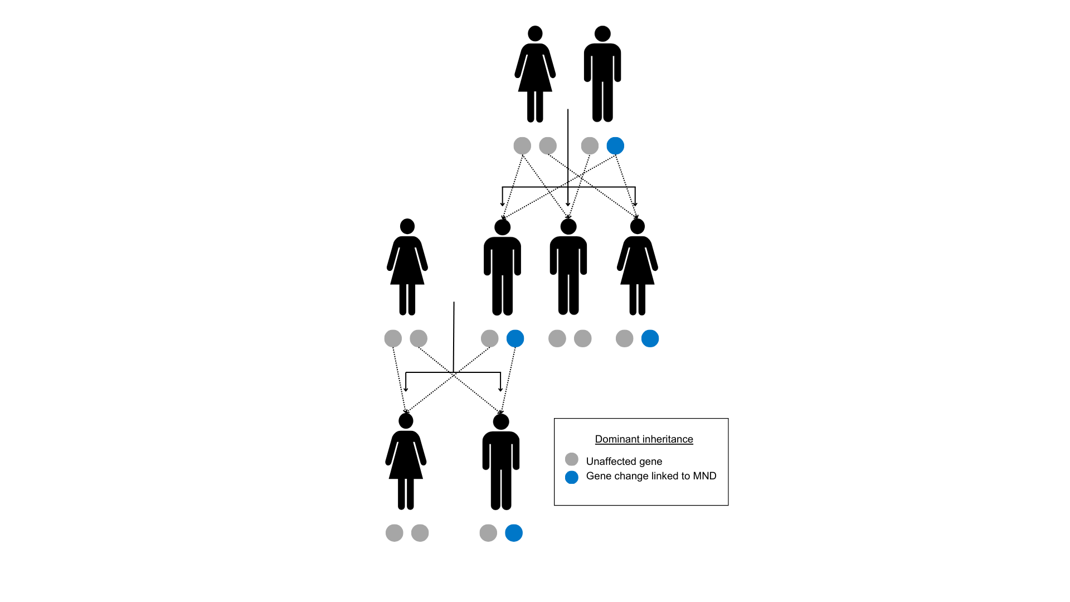

Some people have a rare gene change linked to MND that is passed down from a parent to their child in a different pattern. This recessive inheritance pattern means any children are less likely to inherit the gene change [10, 11].

The chance of each child inheriting the gene change from their parents is the same for each pregnancy. The chance is the same if the baby is a girl or a boy, or looks like their parent or not.

***What is the chance of developing symptoms for people with a gene change***

Not everyone who has a gene change linked to MND will develop symptoms of the disease in their lifetime. Scientists and doctors cannot explain why some people with a gene change develop MND, and others do not. They have found that the chance of this happening may be higher or lower depending on the gene change [2]. They cannot predict the chance for any ******one person. The term penetrance is used by scientists to describe the chance a person with a gene change linked to a disease will get that disease.

***What is the chance a person with MND will be found to have a gene change through genetic testing***

Genetic testing cannot always find a gene change in a person with MND even if they have a family history of MND. This is because scientists have not found all the gene changes linked to MND yet. There may still be an inherited form of MND in the family. If no gene change is found in a person with MND, their family members cannot have predictive genetic testing or reproductive genetic testing.

Some people with MND who have a gene change linked to their disease do not have a known family history of MND. Scientists are more likely to find a gene change linked to MND in people with a family history, than in people without a family history [11, 23, 24].

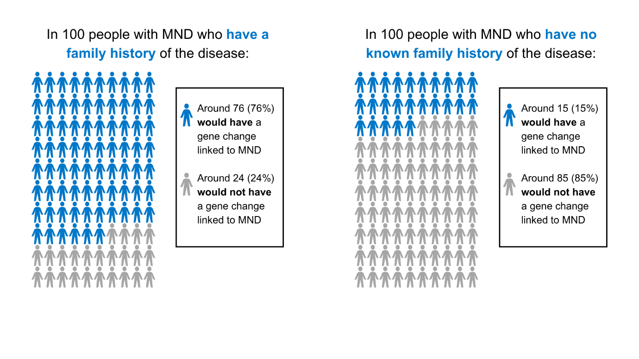

Some people with MND who have a gene change do not know of any relatives who had MND before them. There are many reasons why people may not know of other family members with MND. Family members may have been diagnosed with a different illness such as FTD, or they may have had the gene change but not got MND symptoms in their lifetime.

***Use this space to jot down your thoughts or questions. You can use these notes when talking with your family and healthcare team.***



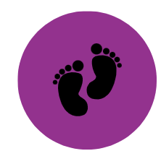**Section E: Options for having a family in MND**

This section has information on options people may think about when planning a family. Many people decide to have a family without having predictive genetic testing. Others decide to have predictive genetic testing before making plans for a family. This section may be relevant for you if you are thinking about having children.

**What options are available depends on each person’s situation. Options people might think about when having children include:**

* Have children without any extra testing (accept the chance of having a child with the gene change linked to MND)
* Adoption
* Egg or sperm donation
* Surrogacy
* Pre-implantation genetic testing (PGT)
* Prenatal testing (PNT)

**People have different views on these options based on their personal goals, values and what feels right for their family** [12-14]**. Views may change over time.**

**Map of reproductive options for people with MND in the family**

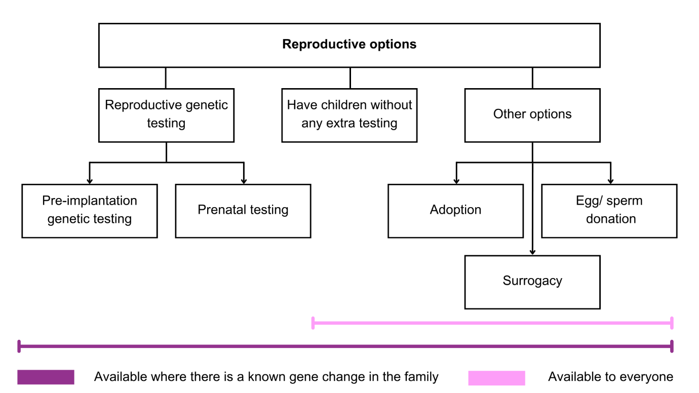



This rest of this section gives information about pre-implantation genetic testing (PGT) and prenatal testing (PNT). These options may be offered to people who know the gene change linked to MND in their family.

**Reproductive genetic testing options**

Pre-implantation genetic testing and prenatal testing are types of reproductive genetic testing. People may be interested in finding out about these options if they wish to have a biological child without the chance of passing on the gene change linked to MND.

Some people find having predictive genetic testing helps them make decisions about using reproductive genetic testing. There may be ways of using these options for people who have a gene change linked to MND in their family but do not want to have predictive genetic testing themselves. People can check with their healthcare team about what options are available to them.

Some people find making these reproductive genetic testing decisions difficult. These options can have physical, emotional and financial consequences for couples, and their families. The two reproductive genetic testing options are:

***Pre-implantation genetic testing (PGT)*** is a type of testing that involves usingin vitro fertilisation (IVF). The egg is fertilised with the sperm in a laboratory, to make an embryo. Embryos are then tested to see if they have the gene change linked to MND. Only embryos without the gene change are put into the womb, with the hope they will continue into a pregnancy. PGT is sometimes called pre-implantation genetic diagnosis (PGD). There are guidelines that say who can have PGT paid for on the NHS.

***Prenatal testing (PNT)*** is a type of testing that can be used during pregnancy. From 11 weeks of pregnancy, tests can be carried out to see if the fetus (developing baby) has the gene change linked to MND. These tests are usually carried out through one of two methods, called chorionic villus sampling (CVS) or amniocentesis. The PNT result can either be positive, the fetus does have the gene change; or negative, the fetus does not have the gene change. If the test result is positive for the gene change, the couple consider ending the pregnancy. There is a small chance that the procedures used in PNT can cause the loss of the pregnancy (miscarriage). PNT is sometimes called prenatal diagnosis (PND).



People making reproductive genetic testing decisions can talk with a member of their healthcare team about their options. Genetic counsellors can talk about reproductive genetic testing decisions and help people think through what is important to them. Section F includes links to more information on options for having a family.

***Use this space to jot down your thoughts or questions. You can use these notes when talking with your family and healthcare team.***



**Section F: Further information - glossary, resources, references and project details**

**Glossary**

Below is a list of words that you might hear when talking about MND and genetic testing, together with their meaning.

|  |  |
| --- | --- |
| **Term** | **Description of term** |
| Clinical trial | A clinical trial is a type of research study which looks to see whether treatments or interventions are safe and effective (how well they work). Often, this is studied by comparing people who have been given the treatment or intervention with people who have not been given it. |
| Dominant inheritance | Autosomal dominant inheritance means it takes just one copy of a gene change for a person to develop the disease. Each child of a person with this kind of gene change has a 50% (1 in 2) chance of getting it from their parent. |
| Frontotemporal dementia | Frontotemporal dementia (FTD) is the name for a group of health problems which can cause changes to personality and behaviour, problems with language, and difficulties with concentration, planning and organisation. FTD is sometimes called frontal lobe dementia or Pick’s disease. |
| Gene | Genes are instructions which tell our bodies how to work and grow. They control or influence traits such as eye colour and height. Genes are passed down from parents to their child when they become pregnant. |
| Gene change | Sometimes changes or mistakes are made in our genetic code, which can change how a gene works. Some of these gene changes can cause health problems. A gene change that can cause a health problem is sometimes called a pathogenic gene variant or gene mutation. |
| Genetically targeted treatment | Genetically targeted treatments are drugs that target a particular gene change to try and make the gene work as it should do, or stop it working in a harmful way. Tofersen is a genetically targeted treatment. |
| Genetic counselling | Genetic counselling helps people to understand their risk of having a genetic condition, what it could mean for themselves and their family, and their options, including around genetic testing. It is carried out by a specialist in genetic conditions (a genetic counsellor or a genetics consultant) and usually involves having several appointments over a period of time. People can ask their GP for a referral. |
| Genetic counsellor  Section F logo | Genetic counsellors are trained health professionals who support families with genetic health problems to understand and think about what this means for them. They can support people to think through their options, including around genetic testing. |
| Genome | A genome is a person’s entire genetic code. It contains all their genes as well as the other sections in between which are less well understood. |
| Inheritance | Inheritance is the way genetic information is passed down through generations, from a parent to their child. |
| Inherited motor neuron disease | Sometimes, MND is caused by a change in a gene that is passed down in families. This is known as inherited, familial or genetic MND. |
| Motor neuron disease | Motor neuron disease (MND) is a disease that stops signals reaching the muscles, which causes the muscles to stop working. Some people also experience changes to their thinking, behaviour and emotions. MND is also called amyotrophic lateral sclerosis (ALS). |
| Neurological | Neurological diseases are health problems that affect the brain, spinal cord and nerves, known as the nervous system. |
| Neurologist | A neurologist is a doctor who has done specialist training in neurological diseases. Neurologists are trained to diagnose and treat people with neurological symptoms. |
| Penetrance | Penetrance means the chance that a person with a gene change will get the disease. If a gene change is not fully penetrant not everyone who has the gene change will get symptoms of the disease in their lifetime. |
| Predictive genetic testing | Predictive genetic testing is a type of genetic testing. It can be used by people who have a family member with a gene change linked to MND. Having a predictive test tells them if they have the same gene change, or not. People with the gene change have a higher chance of developing MND in the future. |
| Pre-implantation genetic testing | Pre-implantation genetic testing (PGT) uses a process of in vitro fertilisation (IVF). Embryos are made in a laboratory and genetically tested to see if they have the gene change linked to the health problem. Only embryos that do not have the gene change can continue to a pregnancy. |
| Prenatal testing | Prenatal testing (PNT) involves genetically testing a pregnancy to see if the fetus (developing baby) carries the gene change linked to the health problem that has been found in the family. |
| Recessive inheritance | Autosomal recessive inheritance means it takes two copies of a gene change for a person to get the disease, one passed down from each parent. Where both parents have a recessive gene change, each of their children have a 25% (1 in 4) chance of getting two copies. |
| Reproductive genetic testing | Reproductive genetic testing is a type of genetic testing that can be done either before pregnancy (pre-implantation genetic testing) or during pregnancy (prenatal testing). This can be used by some people who have a gene change linked to MND and want to have children without passing it on. It can sometimes be used by family members with a chance of having a gene change. |
| Tofersen | Tofersen is a genetically targeted treatment designed to treat MND caused by changes in the *SOD1* gene. It has been shown to slow down the progress of the disease. |
| Whole genome sequencing | Whole genome sequencing (WGS) is a type of genetic testing which looks at the person's whole genome - all their genetic code rather than just specific genes. WGS may be offered to people with MND in England. |



**Information and support resources**

Below are some resources and links which you can use to find more information about the topics raised in this decision aid.

***Key organisations offering information and support***

* MND Association: <https://www.mndassociation.org/> including section ‘Inherited MND’: <https://www.mndassociation.org/about-mnd/mnd-explained/inherited-mnd>
* MND Scotland: <https://mndscotland.org.uk/>
* MND Association Northern Ireland: <https://www.mndani.com/>
* FTD talk: <https://www.ftdtalk.org/>
* Rare Dementia Support: <https://www.raredementiasupport.org/>
* Healthtalk section on inherited MND: <https://hexi.ox.ac.uk/Familial-MND/overview>
* Genetic Alliance: <https://geneticalliance.org.uk/>
* Your Genome: <https://www.yourgenome.org/>
* Your clinical team

***Research and clinical trial information***

* MND Association: <https://www.mndassociation.org/research/research> (UK based)
* UK MND Clinical Studies Group: <https://www.mndcsg.org.uk/home> (UK based)
* UK MND Research Institute: <https://ukmndri.org/> (UK based)
* ALS.org: <https://www.als.org/research/als-research-topics> (US based)
* NEALS (Northeast ALS Consortium): <https://neals.org/> (US based)

***Genetic testing and insurance***

* Genetic Alliance UK: https://geneticalliance.org.uk/insurance-and-genetic-conditions-faqs/
* MND Connect: <https://www.mndassociation.org/support-and-information/our-services/mnd-connect>
* The Association of British Insurers: <https://www.abi.org.uk/data-and-resources/tools-and-resources/genetics/>

***Family planning and reproductive genetic testing***

* MND Association information sheet B3 ‘Inherited MND: Options when starting a family’, available at: [www.mndassociation.org](http://www.mndassociation.org)
* Human Fertilisation & Embryology Authority, information on pre-implantation genetic testing for monogenic disorders (PGT-M): <https://www.hfea.gov.uk/treatments/embryo-testing-and-treatments-for-disease>

**References**

The references below show the evidence used to develop this decision aid. Please get in touch using the contact details provided if you cannot access any of the references.

[1] Royal College of Physicians, Royal College of Pathologists and British Society for Genetic Medicine. Consent and confidentiality in genomic medicine: Guidance on the use of genetic and genomic information in the clinic. 3rd edition. Report of the Joint Committee on Genomics in Medicine. London: RCP, RCPath and BSGM, 2019.

[2] Douglas AG, Baralle D. Reduced penetrance of gene variants causing amyotrophic lateral sclerosis. Journal of Medical Genetics. 2024 Mar 1;61(3):294-7.

[3] MacLeod R, Tibben A, Frontali M, Evers‐Kiebooms G, Jones A, Martinez‐Descales A, Roos RA, Editorial Committee and Working Group ‘Genetic Testing Counselling’ of the European Huntington Disease Network. Recommendations for the predictive genetic test in Huntington's disease. Clinical genetics. 2013 Mar;83(3):221-31.

[4] Crook A, Williams K, Adams L, Blair I, Rowe DB. Predictive genetic testing for amyotrophic lateral sclerosis and frontotemporal dementia: genetic counselling considerations. Amyotrophic lateral sclerosis and frontotemporal degeneration. 2017 Oct 2;18(7-8):475-85.

[5] Howard J, Chaouch A, Douglas AG, MacLeod R, Roggenbuck J, McNeill A. Genetic testing for monogenic forms of motor neuron disease/amyotrophic lateral sclerosis in unaffected family members. European Journal of Human Genetics. 2024 Nov 5:1-7.

[6] National Institute for Health and Care Excellence (NICE). Motor neurone disease: assessment and management. NICE guideline [NG42]. [Internet]. Nice.org.uk. 2019. Available from: <https://www.nice.org.uk/guidance/ng42>

[7] Roggenbuck J, Eubank BH, Wright J, Harms MB, Kolb SJ, ALS Genetic Testing and Counseling Guidelines Expert Panel, Ajroud‐Driss S, Arcila Londono X, Bauer G, Benatar M, Bedlack R. Evidence‐based consensus guidelines for ALS genetic testing and counseling. Annals of clinical and translational neurology. 2023 Nov;10(11):2074-91.

[8] NHS England. National Genomic Test Directory [Internet]. England.nhs.uk. 2018. Available from: <https://www.england.nhs.uk/publication/national-genomic-test-directories/>

[9] NHS East Genomics. Whole genome sequencing for a rare disease, information for patients and family members. Genomic Medicine Service. [Internet]. Eastgenomics.nhs.uk. Available from: <https://www.eastgenomics.nhs.uk/for-patients-and-carers/considering-whole-genome-sequencing/>

[10] Goutman SA, Hardiman O, Al-Chalabi A, Chió A, Savelieff MG, Kiernan MC, Feldman EL. Emerging insights into the complex genetics and pathophysiology of amyotrophic lateral sclerosis. The Lancet Neurology. 2022 May 1;21(5):465-79.

[11] Akçimen F, Lopez ER, Landers JE, Nath A, Chiò A, Chia R, Traynor BJ. Amyotrophic lateral sclerosis: translating genetic discoveries into therapies. Nature Reviews Genetics. 2023 Sep;24(9):642-58.

[12] Crook A, Jacobs C, Newton-John T, Richardson E, McEwen A. Patient and relative experiences and decision-making about genetic testing and counseling for familial ALS and FTD: a systematic scoping review. Alzheimer Disease & Associated Disorders. 2021 Oct 1;35(4):374-85.

[13] Howard J, Forrest Keenan K, Mazanderani F, Turner MR, Locock L. Experiences of predictive genetic testing in inherited motor neuron disease: Findings from a qualitative interview study. Journal of genetic counseling. 2025 Feb;34(1):e1904.

[14] Howard J, Mazanderani F, Keenan KF, Turner MR, Locock L. Fluctuating salience in those living with genetic risk of motor neuron disease: A qualitative interview study. Health Expectations. 2024 Apr;27(2):e14024.

[15] Howard J, Bekker HL, McDermott CJ, McNeill A. Predictive genetic testing in amyotrophic lateral sclerosis (ALS): experiences of decision-making within UK genetic counselling services [under review].

[16] Fontaine M, Horowitz K, Anoja N, Genge A, Salmon K. How the prospect of a clinical trial impacts decision-making for predictive genetic testing in ALS. Amyotrophic Lateral Sclerosis and Frontotemporal Degeneration. 2024 Nov 7:1-9.

[17] Witteman HO, Ndjaboue R, Vaisson G, Dansokho SC, Arnold B, Bridges JF, Comeau S, Fagerlin A, Gavaruzzi T, Marcoux M, Pieterse A. Clarifying values: an updated and expanded systematic review and meta-analysis. Medical Decision Making. 2021 Oct;41(7):801-20.

[18] Ottawa Personal Decision Guide © 2015 O’connor, Stacey, Jacobsen. Ottawa Hospital Research Institute & University of Ottawa, Canada

[19] Ferron Parayre A, Labrecque M, Rousseau M, Turcotte S, Légaré F. Validation of SURE, a four-item clinical checklist for detecting decisional conflict in patients. Medical Decision Making. 2014 Jan;34(1):54-62.

[20] Talbot K. Motor neuron disease: the bare essentials. Practical neurology. 2009 Oct 1;9(5):303-9.

[21] Van Damme P, Al‐Chalabi A, Andersen PM, Chiò A, Couratier P, De Carvalho M, Hardiman O, Kuźma‐Kozakiewicz M, Ludolph A, McDermott CJ, Mora JS. European Academy of Neurology (EAN) guideline on the management of amyotrophic lateral sclerosis in collaboration with European Reference Network for Neuromuscular Diseases (ERN EURO‐NMD). European journal of neurology. 2024 Jun;31(6):e16264.

[22] Miller TM, Cudkowicz ME, Genge A, Shaw PJ, Sobue G, Bucelli RC, Chiò A, Van Damme P, Ludolph AC, Glass JD, Andrews JA. Trial of antisense oligonucleotide tofersen for SOD1 ALS. New England Journal of Medicine. 2022 Sep 22;387(12):1099-110.

[23] Salmon K, Kiernan MC, Kim SH, Andersen PM, Chio A, Van den Berg LH, Van Damme P, Al-Chalabi A, Lillo P, Andrews JA, Genge A. The importance of offering early genetic testing in everyone with amyotrophic lateral sclerosis. Brain. 2022 Apr 1;145(4):1207-10.

[24] Shepheard SR, Parker MD, Cooper-Knock J, Verber NS, Tuddenham L, Heath P, Beauchamp N, Place E, Sollars ES, Turner MR, Malaspina A. Value of systematic genetic screening of patients with amyotrophic lateral sclerosis. Journal of Neurology, Neurosurgery & Psychiatry. 2021 May 1;92(5):510-8.

**Patient decision aid standards**

Elwyn G, O'Connor A, Stacey D, Volk R, Edwards A, Coulter A, Thomson R, Barratt A, Barry M, Bernstein S, Butow P. Developing a quality criteria framework for patient decision aids: online international Delphi consensus process. Bmj. 2006 Aug 24;333(7565):417.

Stacey D, Volk RJ, IPDAS Evidence Update Leads (Hilary Bekker, Karina Dahl Steffensen, Tammy C. Hoffmann, Kirsten McCaffery, Rachel Thompson, Richard Thomson, Lyndal Trevena, Trudy van der Weijden, and Holly Witteman). The International patient decision aid standards (IPDAS) collaboration: evidence update 2.0. Medical Decision Making. 2021 Oct;41(7):729-33.

Stacey D, Lewis KB, Smith M, Carley M, Volk RJ, Douglas EE, Pacheco-Brousseau L, Finderup J, Gunderson J, Barry M, Bennette CL, Bravo P, Dahl Steffensen K, Gogovor A, Graham ID, Kelly SE, Legare F, Sondergaard H, Thomson R, Trenaman L, Trevena L. [Decision aids for people facing health treatment or screening decisions.](https://www.cochranelibrary.com/cdsr/doi/10.1002/14651858.CD001431.pub6/full) Cochrane database of systematic reviews. 2024.

**Project details**

***Development of this decision aid***

This decision aid was developed by a study team from the Universities of Sheffield and Leeds. This decision aid is based on our research into how people make decisions about genetic testing for MND. Our study steering group included family members with lived experience of MND, health professionals, and people from the MND Association. We wish to thank everyone who has advised our study and taken part in our research.

***The study team***

Alisdair McNeill - Consultant in Clinical Genetics at Sheffield Children’s Hospital and Senior Clinical Lecturer in Neurogenetics at University of Sheffield

Hilary Bekker - Professor of Medical Decision Making at University of Leeds

Chris McDermott - Consultant Neurologist at Sheffield Teaching Hospitals and Professor of Translational Neurology at University of Sheffield

Jade Howard - Postdoctoral Researcher at University of Sheffield

***The steering group***

Jennie Starkey - Expert by experience

Christine Hoskin - Expert by experience

Calum Kendal - Expert by experience

Jennifer Beford - Head of Partnerships, Education and Information at the MND Association

Angela Genge - Executive Director of the Clinical Research Unit and Director of the ALS

Global Centre of Excellence, Montreal Neurological Institute; Chief medical officer, QurAlis

Kristiana Salmon - MND research & independent consultant; previously, academic research focused on genetic counselling and testing access and clinical practice in Canada

Martin Turner - Professor of Clinical Neurology & Neuroscience at Oxford University and Consultant Neurologist at the John Radcliffe Hospital

***Project funding***

This research was funded by the Motor Neurone Disease Association (2022-2025).

***Studies carried out to inform the decision aid***

Howard J, Bekker HL, McDermott CJ, McNeill A. A report of resources used by clinicians in the UK to support motor neuron disease genomic testing. Amyotrophic Lateral Sclerosis and Frontotemporal Degeneration. 2024 Apr 2;25(3-4):410-2.

Howard J, Bekker HL, McDermott CJ, McNeill A. Survey of service needs to embed genome sequencing for motor neuron disease in neurology in the English National Health Service. Journal of Medical Genetics. 2024 Jul 1;61(7):661-5.

Howard J, Bekker HL, McDermott CJ, McNeill A. Exploring the needs and preferences of people with amyotrophic lateral sclerosis (ALS) when making genomic testing decisions: an interview study. Amyotrophic Lateral Sclerosis and Frontotemporal Degeneration. 2025 Feb 27:1-8.

Howard J, Bekker HL, McDermott CJ, McNeill A. Predictive genetic testing in amyotrophic lateral sclerosis (ALS): experiences of decision-making within UK genetic counselling services [under review].

***Referencing the decision aid***

Howard J, McNeill A, McDermott CJ, Bekker HL. Predictive genetic testing and motor neuron disease: A decision aid. 2025. Available from: https://mymndgenetest.shef.ac.uk

***Conflicts of interest***

The authors have no conflicts of interest, financial or otherwise. This decision aid was developed from a research grant funded by the MND Association after external peer review. The funders, study team, steering committee and their employers do not stand to benefit from the decisions people make after reading this booklet.

***Contact***

Alisdair McNeill, Sheffield Institute for Translational Neuroscience, University of Sheffield.

✉️ [a.mcneill@sheffield.ac.uk](mailto:a.mcneill@sheffield.ac.uk)