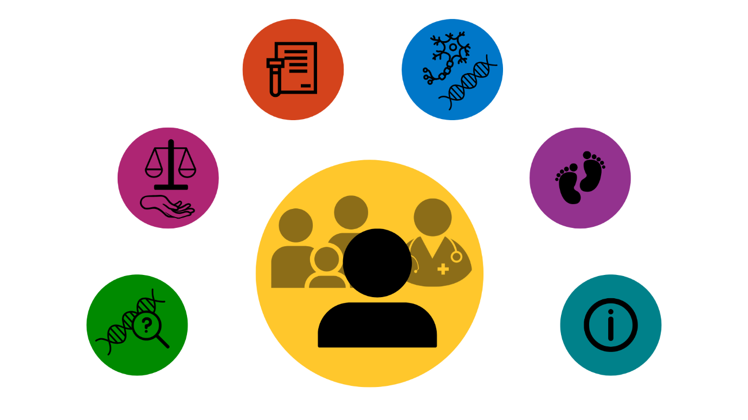

**Genetic testing and motor neuron disease**

**A decision aid**

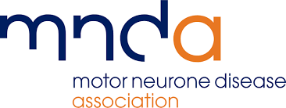

**About this decision aid**

This decision aid is designed to help you think about your options around genetic testing in motor neuron disease (MND). In some countries, MND is known as Amyotrophic Lateral Sclerosis (ALS).

Making a decision about genetic testing is personal to you, and your life. Your decision may have consequences for you, and your family. Your views about genetic testing may change over time.

This decision aid has information about three testing options:

* **Not have genetic testing**
* **Store a DNA sample, decide about testing later**
* **Have genetic testing**

This decision aid has prompts to help you think about what is important to you. These prompts can help you talk about your options with your family, and health professionals.

The genetic testing and motor neuron disease decision aid was developed by researchers at the Universities of Sheffield and Leeds, families living with MND, and health professionals. Our research was funded by the Motor Neurone Disease Association.



**Disclaimer:** Every effort has been made to provide accurate information. However, facts about genetics in MND and genetic testing can change over time. Check with your local MND team about the facts you are using when making decisions.

This resource was last updated in June 2025.

**Contents**

**Section A:** Genetic testing decisions for people with MND………………………………......3-9

**Section B:** Making my decision about genetic testing………………………………….......10-16

**Section C:** The MND genetic testing process………………………………………….……17-20

**Section D:** MND and genetics…………………………………………………………………21-25

**Section E:** Options for having a family in MND…………………………………………......26-28

**Section F:** Further information - glossary, resources, references and project details…..29-36

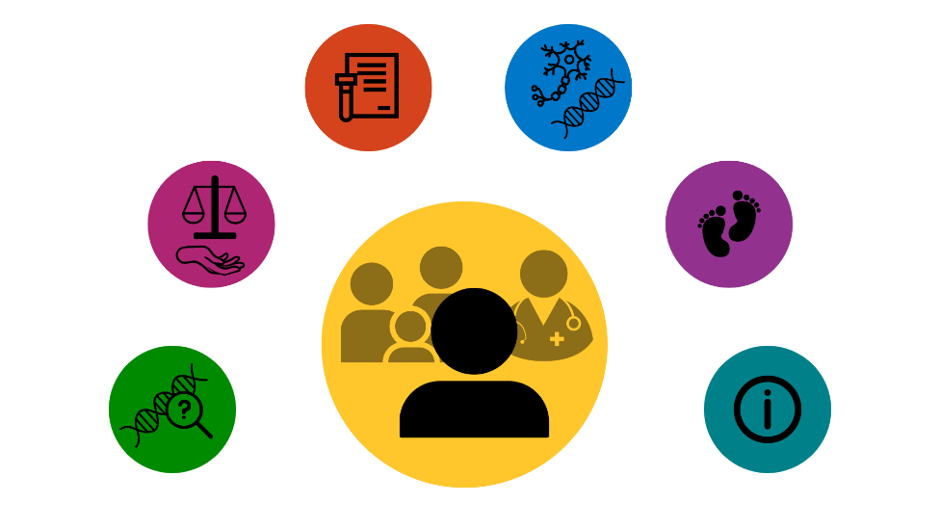

In this decision aid you will find:

* **Written information** to give you facts when making this decision.
* **Decision maps** tolay out the testing options.
* **Tables** to give a summary about each option and the consequences.
* **Diagrams** to show steps and processes around genetic testing.
* **Prompts and writing spaces** to give you a space to jot down your thoughts and questions.

People use this decision aid in different ways. You may like to read it from beginning to end, or dip in and out of sections when you feel ready. You might find it helpful to talk through your decision with your family, friends and health professionals. Use this decision aid in the way that suits you best.

This decision aid includes facts scientists and health professionals use to guide care. In this decision aid, we use numbers in brackets to link our facts with scientific papers and other references, for example [6] or [13]. You can find the list of references in Section F. Section F also includes links to other resources that you or your family members may find useful.

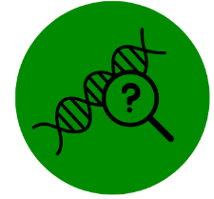**Section A: Genetic testing decisions for people with MND**

This section is designed to help you think about your options around genetic testing.

Genetic testing is a type of test that can tell people with MND if they have a gene change linked to their MND. Some people call this a *diagnostic test,* even though it is carried out after the diagnosis. Having, or not having, genetic testing will not change your diagnosis of MND.

In England, all people with MND can choose to have genetic testing [1]. In other areas, people can check with their healthcare team about what options are offered.

The three options for people with MND when making genetic testing decisions are:

* **Not have genetic testing**
* **Store a DNA sample, decide about testing later**
* **Have genetic testing**

Genetic testing is a personal decision. It is up to you to decide if you want to have genetic testing, or not, at a time that is right for you. Your decision may change over time.

**Being diagnosed with MND**

People are diagnosed with MND by specialist doctors known as neurologists based on their symptoms. People are referred to neurology services by GPs (general practitioners). Once people are diagnosed, the neurology team offer choices about care [2-4]. This includes being offered genetic testing [1, 5]. Everyone’s experience of being diagnosed with MND is different. People make different decisions to manage their MND in a way that best suits their life. Some people wish to find out about genetic testing. Some people do not feel it is important to them, or do not feel ready to find out more at this time [6-8]. Section D has information about MND.

**Decision map: Genetic testing decisions and consequences**

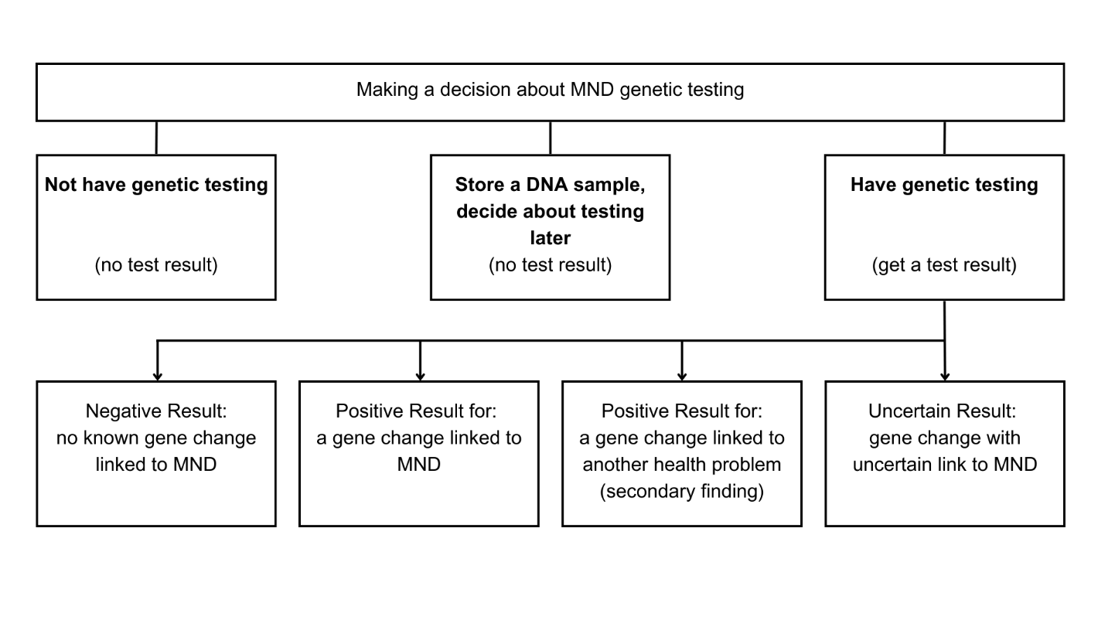

**Genetic testing and MND**

Genetic testing can tell you if your condition is caused by a change in a known gene. About 80-90% of people with MND do not have a form of MND linked to a gene change (known as sporadic MND). This means scientists and doctors do not know the cause of their disease. About 10-20% of people with MND have a form of MND linked to a gene change [9, 10].

When MND is caused by a gene change, and passed down in families, this is known as inherited MND. People with an inherited form of MND have a 50% (1 in 2) chance of passing the gene change to each of their children [9, 10]. Not everyone with a gene change linked to MND will get MND in their lifetime [11].

Some gene changes linked to MND are also linked to other neurological health problems, including frontotemporal dementia (FTD) [9, 10]. People with these gene changes may get MND, FTD or both diseases. Some people will not get either disease. Section D has information about genetics in MND.

***Possible results of genetic testing***

MND genetic testing is carried out through a technique called whole genome sequencing (WGS) [12]. WGS means a person’s whole genetic code is studied. WGS means scientists sometimes find a gene change linked to another health problem. If you have WGS, there are four possible results you could receive:

* **Negative result** – You do not have a gene change known to be linked to MND at this time. Most people with this result do not have an inherited form of MND. A small number of people do have an inherited form of MND, but the gene change linked to their disease has not been found yet [9]. This is more likely for people with a history of MND in their family. Scientists are carrying out studies to find new genes linked to MND. They may let you know if a new gene is found.
* **Positive result for a gene change linked to MND** – You have a gene change known to be linked to MND. This result means you have an inherited form of MND. Other members of your family have a chance of having this same gene change. The most common gene changes linked to inherited MND are: *SOD1*, *TARDBP*, *FUS*, and *C9orf72* [9, 10].
* **Positive result for another health problem**– You have a gene change known to be linked to another health problem [12]. This result is called a secondary finding. This result is not related to your MND. It may have other consequences for you and your family. WGS only looks for certain health problems. You will only be told about other health problems that can be treated.
* **Uncertain result** – You have a gene change known as a variant of uncertain significance (VUS). Scientists and doctors may not be sure if this finding is the cause of your MND, or not. You may be offered more tests to look into this. It is not always possible to say what this result means for you and your family at this time [12].

Sometimes, people find out they have more than one gene change [13] – for example, you could have a gene change linked to MND and a VUS, or a secondary finding and a VUS.

If a gene change linked to MND has already been found in your family, you might be offered a different type of genetic test, to look for this gene change only. You might not find out about secondary findings or VUS results. Your healthcare team can help you understand your options and the consequences.

**Making a decision to know, or not to know, about having a gene change linked to your MND**

When making this decision, you might think about what difference knowing if you have a gene change linked to your MND, or not, will make to your life and the lives of your family members. Some people find the following issues important to their decision making:

***Personal wellbeing and coping***

You may think about what else is happening in your life, and in your wider family, when making a decision about having genetic testing or not. You may be adjusting to the diagnosis of MND and all of the changes that MND brings. You might think about if you would cope better knowing, or not knowing, your genetic test result.

It can take a long time to receive results from genetic testing. When results are ready, you may think about if it is the right time to be given this information.

***Consequences For Family***

When thinking about genetic testing, you may think about what your decision means for your children, other relatives, and future family planning decisions.

Some people find it helpful to talk about the genetic testing decision with relatives. Others find it difficult to talk about the chance of MND having a genetic link, and genetic testing decisions. Within families, people may have similar or different views about genetic testing.

Having genetic testing may give information about the chance other relatives, including children, could get MND. Finding out about a gene change in the family can raise many emotions for families. Some people feel it is helpful to know this information. Some people worry about how this knowledge will affect their lives. Sometimes, family members have strong feelings about whether they want to know their relative’s genetic test results, or not. You may find it helpful to think through how you would share your test results with family members.

If you are found to have a gene change linked to MND (a positive result), your family members may want to think about predictive genetic testing [14, 15]. You, or your family members, may be interested in reproductive genetic testing (see Section E). It can be useful to talk through these options with genetic counsellors and other health professionals.

**Predictive genetic testing** isa test for people who have a gene change linked to MND in their family, but who do not have MND symptoms themselves. People who have this test get either a negative test result (they do not have the gene change linked to MND), or a positive result (they do have the gene change linked to MND). Getting a positive test result means they have a higher chance of developing MND in their lifetime. This genetic test is also known as pre-symptomatic testing*.*

**Reproductive genetic testing** is a type of genetic testing that can be used before, or during, pregnancy. The two types of reproductive genetic testing are prenatal testing (PNT) and pre-implantation genetic testing (PGT). These options are used by people with a genetic condition, or their family members, who wish to have a biological child without the chance of passing on the gene change.

***Consequences For Treatment***

Your healthcare team will offer you treatments to manage your symptoms and have the best quality of life possible [2, 3].

For most people, having or not having genetic testing will not affect the treatments they are offered. Some people with a change in the *SOD1* gene may be offered a genetically targeted treatment known as tofersen. Studies show that for some people, tofersen can slow down the progress of their disease [16]. Scientists are carrying out research into treatments targeting other gene changes linked to MND [9].

***Consequences for taking part in research***

People with MND may wish to take part in research studies to understand MND, and improve treatment and care. Many research studies are open to people whether they have had genetic testing or not. Taking part in research is a personal decision. Your healthcare is not linked to decisions about research.

All studies have a list of guidelines which say who can take part (eligibility criteria). For example, studies researching gene changes linked to MND, and genetically targeted treatments, may be offered to people with particular gene changes. You can talk about taking part in studies with your health professionals and the research team for each study. Links to information about research and how to take part are available in Section F.



***Consequences for insurance and other financial issues***

Genetic test results are stored confidentially in people’s medical records. Companies will not be told if you have had genetic testing or not.

Some people feel worried about the impact of genetic testing for their family members. It is important to be honest about the family history of different health conditions with insurers, but people do not have to share information about predictive genetic testing for MND. Other countries may have different laws. Links to more information about genetic testing and insurance are available in Section F.

You do not have to pay for genetic testing and DNA storage in the UK, as it is offered on the NHS. There may be costs for genetic testing and DNA storage in other countries.

**Thinking about what matters most to you**

You might find it helpful to think through some of the following questions when making your decision:



* How important is it for me to know whether or not I have a gene change linked to MND?
* How much do I need to know about the cause of my MND?
* How would I cope with knowing I have, or do not have, a gene change linked to MND?
* How much do I want to find out if I could take part in research studies targeting particular gene changes?
* How important is it for me to know the chance of passing on a gene change linked to MND when speaking with relatives?
* How important is it for me to know the chance of passing on a gene change linked to MND when planning a family?

***Use this space to jot down your thoughts or questions. You can use these notes when talking with your family and healthcare team.***



**Section B: Making my decision about genetic testing**

People have different reasons for choosing the genetic testing option that suits their life best [6-8]. This section prompts you to explore what is important to you about each option. It helps you think about which option is right for you at this time.

You might feel sure about your decision. You might feel unsure or have mixed views. Your views on genetic testing may change over time. The decision map shows options open to people if their views change.

**Decision map: Genetic testing decisions and options for changing the decision**

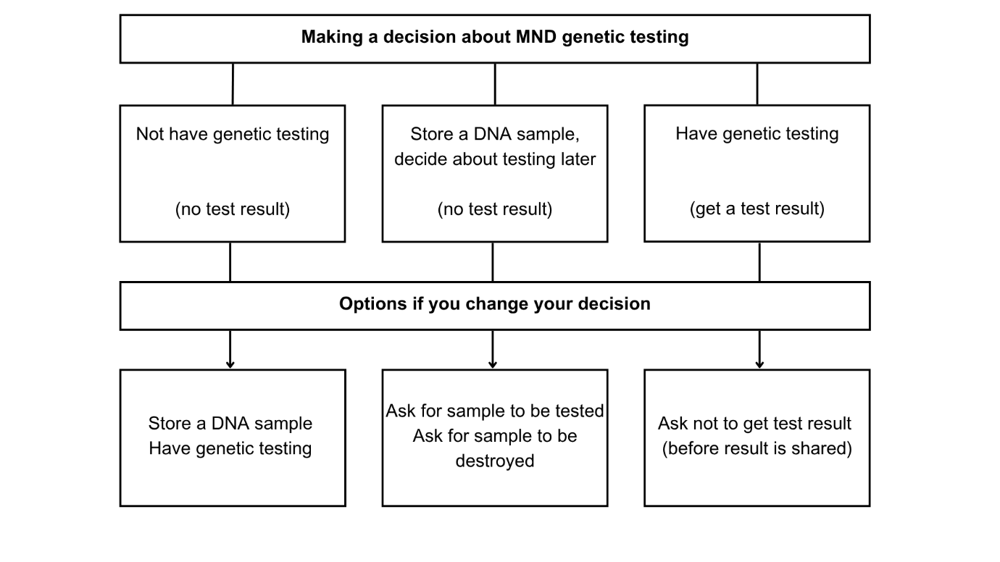

**Option: Not have genetic testing**

Deciding not to have genetic testing means you will not find out if your MND is caused by a known gene change that can be passed down in families.

Below are some consequences you might think about for this option:

* You can focus on managing your MND symptoms and planning your care with health professionals.
* You will not be able to have a genetically targeted treatment (if available).
* You will not be able to take part in a clinical trial looking at a geneticallytargeted treatment(if available).
* You can choose to take part in studies about MND treatment and care.
* You cannot have reproductive genetic testing.
* You will not know if there is an inherited form of MND in the family. You will not know if your family members could have a higher chance of getting MND.
* Your relatives cannot make decisions about predictive genetic testing and reproductive genetic testing.
* You can change your mind at any point, and either store your DNA or have the genetic test.

***You might find it helpful to think about or jot down what is important to you about this option. You can use this to talk with your family or health professionals*** *[17, 18]****.***

|  |  |
| --- | --- |
| ***Reasons I like* the ‘not have genetic testing’ option**  Rate how important each reason is for you, * = slightly important, ** = quite important, *** = very important] | **Importance (*/**/***)** |
|  |  |
|  |  |
|  |  |
| ***Reasons I do not like* the ‘not have genetic testing’ option**  Rate how important each reason is for you, * = slightly important, ** = quite important, *** = very important | **Importance (*/**/***)** |
|  |  |
|  |  |
|  |  |

**Option: Store a DNA sample, decide about testing later**

Deciding to store a DNA sample means you will give a blood sample to be sent to a clinical genetics laboratory. Your DNA will be taken out of this sample and stored securely. You can ask for your DNA sample to be tested later, to find out if you have a gene change. Your sample will stay in storage after you pass away. Your family members would then be able to ask for the sample to be tested. Your DNA sample would not be used for any other reason.

Below are some consequences you might think about for this option:

* You will give a blood sample when asked by your neurology team, and focus on managing your MND symptoms and planning your care with health professionals.
* You will not be able to have a genetically targeted treatment (if available).
* You will not be able to take part in a clinical trial looking at a genetically targeted treatments (if available).
* You can choose to take part in studies about MND treatment and care.
* You cannot have reproductive genetic testing.
* You will not know if there is an inherited form of MND in the family. You will not know if your family members could have a higher chance of getting MND.
* Your relatives cannot make decisions about predictive testing or reproductive testing.
* You can change your mind at any point. You can either ask for your sample to be tested, or ask for your sample to be destroyed so it cannot be tested.

***You might find it helpful to think about or jot down what is important to you about this option. You can use this to talk with your family or health professionals.***

|  |  |
| --- | --- |
| ***Reasons I like* the ‘store a DNA sample’ option**  Rate how important each reason is for you, * = slightly important, ** = quite important, *** = very important] | **Importance (*/**/***)** |
|  |  |
|  |  |
|  |  |
| ***Reasons I do not like* the ‘store a DNA sample’ option**  Rate how important each reason is for you, * = slightly important, ** = quite important, *** = very important] | **Importance (*/**/***)** |
|  |  |
|  |  |
|  |  |

**Option: Have genetic testing**

Deciding to have genetic testing means you will find out if your MND is caused by a known gene change (positive result), or not (negative result). Some people receive an uncertain result (variant of uncertain significance), which may or may not explain why they have MND. Some people find out that they have a gene change linked to another health problem (secondary finding).

Below are some consequences you might think about for this option:

* You will give a blood sample when asked by your neurology team, and focus on managing your MND symptoms and planning your care with health professionals.
* You may experience a range of emotions when waiting for your genetic test results, and when you get your results back. Everyone is affected differently.
* You can decide to delay getting your test result back after testing. Some people decide not to get their test result back at all.

Receiving a positive result has extra consequences:

* If you have a change in the *SOD1* gene, you may be offered a genetically targeted treatment known as tofersen.
* You may be able to take part in a clinical trial testing a genetically targeted treatment (if available).
* You will find out there is an inherited form of MND in your family. Children and other family members have a chance of having the same gene change.
* You may choose to think about reproductive genetic testing options.
* Your family members can make decisions about predictive genetic testing and reproductive genetic testing.

***You might find it helpful to think about or jot down what is important to you about this option. You can use this to talk with your family or health professionals.***

|  |  |
| --- | --- |
| ***Reasons I like* the ‘have genetic testing’ option**  Rate how important each reason is for you, * = slightly important, ** = quite important, *** = very important | **Importance (*/**/***)** |
|  |  |
|  |  |
|  |  |
| ***Reasons I do not like* the ‘have genetic testing’ option**  Rate how important each reason is for you, * = slightly important, ** = quite important, *** = very important | **Importance (*/**/***)** |
|  |  |
|  |  |
|  |  |



**Summary table of information about the three genetic testing options**

|  |  |  |  |
| --- | --- | --- | --- |
|  | **Not have genetic testing** | **Store a DNA sample, decide about testing later** | **Have genetic testing** |
| **The process** | You have the option to discuss genetic testing in a consultation.  You will not sign a consent form or give a blood sample. | You will discuss genetic testing and DNA storage in a consultation.  You will sign a consent form and give a  blood sample. | You will discuss genetic testing in consultation.  You will sign a consent form and give a blood sample.  You will get your results in a follow-up consultation or by letter. |
| **Knowledge about genetic cause** | You will not know if you have a gene change linked to your MND. | You will not know if you have a gene change linked to your MND. | You will find out if your MND is caused by a known gene change (positive result), or not (negative result). Some people receive an uncertain result (VUS). Some people find out if they have a gene change linked to another health problem (secondary finding). |
| **Impact on MND treatment** | You will be offered treatment to manage your MND symptoms. You will not be able to have a genetically targeted treatment (if available). | You will be offered treatment to manage your MND symptoms. You will not be able to have a genetically targeted treatment (if available). | You will be offered treatment to manage your MND symptoms. If you have a *SOD1* gene change you may be offered a genetically targeted treatment called tofersen [16]. |
| **Impact on family** | You will not know if your family members could have a higher chance of getting MND. They cannot choose to have predictive or reproductive genetic testing. | You will not know if your family members could have a higher chance of getting MND. They cannot choose to have predictive or reproductive genetic testing. | If you have a gene change linked to MND, you will know that your family members have a higher chance of getting MND. They may choose to have predictive or reproductive testing. |
| **Connected decisions** | You will not be able to think about reproductive genetic testing.  You will not be able to take part in research studies which only include people with a known gene change. | You will not be able to think about reproductive genetic testing.  You will not be able to take part in research studies which only include people with a known gene change. | If you get a positive result, you may will be able to think about reproductive genetic testing. You may be able to take part in research studies for people with a gene change (if available). |

**Deciding which genetic testing option is right for you**

Given what you have read so far, use the table below to rate how likely you are to choose each of the genetic testing options.

**How likely am I to have these testing options (mark an answer for each option):**

|  |  |  |  |  |  |
| --- | --- | --- | --- | --- | --- |
|  | **No**  **Definitely Not** | **No**  **Maybe** | **Not**  **Sure** | **Yes**  **Maybe** | **Yes**  **Definitely** |
| **Not have genetic testing** |  |  |  |  |  |
| **Store a DNA sample, decide about testing later** |  |  |  |  |  |
| **Have genetic testing** |  |  |  |  |  |

Information about genetic testing in MND is complicated. Use the questions below to see if you need to ask for more information or support before making this decision [19]

**Mark ‘yes’ or ‘no’ for each option:**

|  |  |  |
| --- | --- | --- |
|  | **Yes** | **No** |
| Do you feel sure about the best choice for you? |  |  |
| Do you know the benefits and risks of each option? |  |  |
| Are you clear about which benefits and risks matter most to you? |  |  |
| Do you have enough support and advice to make a choice? |  |  |

***Use this space to jot down your thoughts or questions. You can use these notes when talking with your family and healthcare team.***



**Section C: The MND genetic testing process**

This section describes the genetic testing process in the UK. Your healthcare team can share information about the process in your local area and timings involved. The genetic testing process happens alongside the care you get from your neurology team.

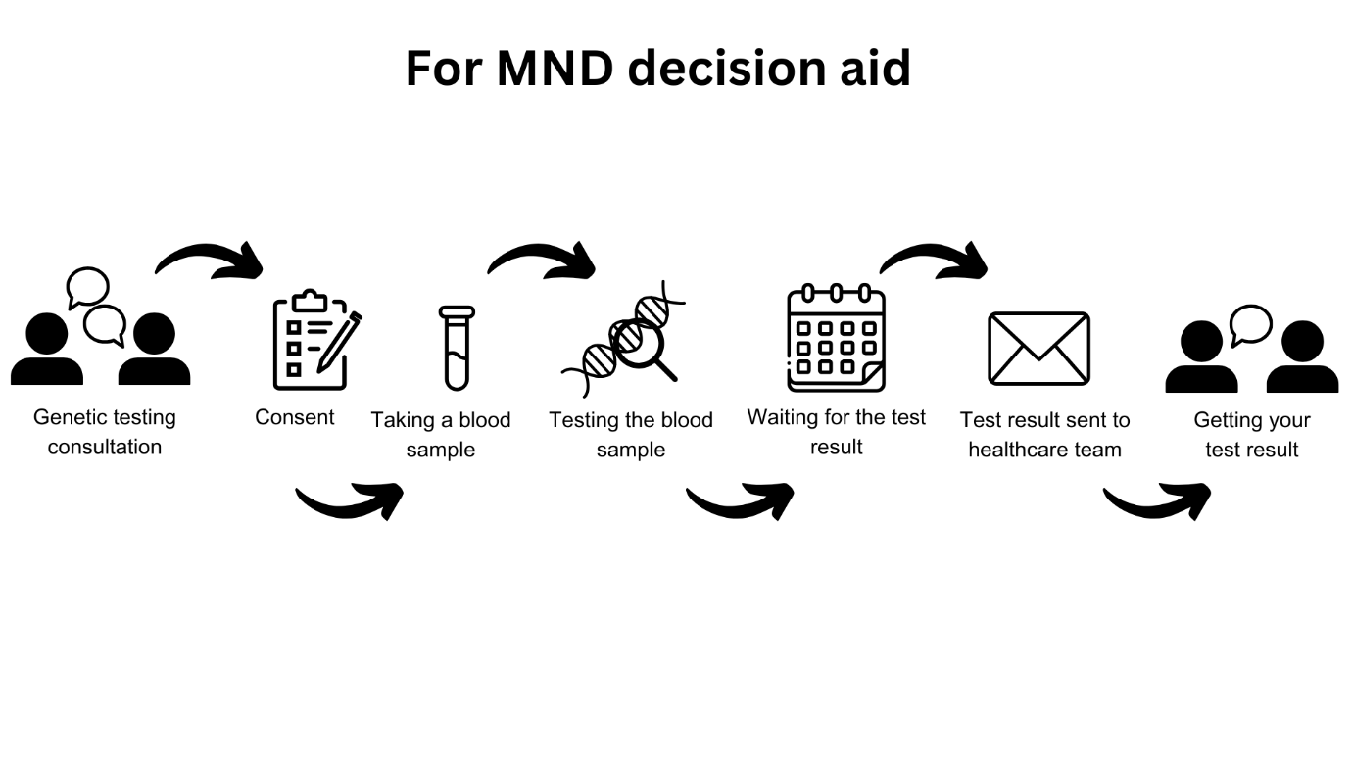

|  |  |
| --- | --- |
| An image showing the genetic testing consultation | **Genetic testing consultation:** Your neurology team may offer you genetic testing after your diagnosis, or you might choose to ask about your options. You might be offered the chance to speak with a genetic counsellor or clinical geneticist in a separate appointment.  In your consultation, you may talk about genes linked to MND, your family history, and what genetic testing means for you and your family [5]. You can have a spouse, family member or friend in the consultation for support, and to ask questions.  You do not need to make a decision about genetic testing in this consultation. You may wish to take some time to think about the options, and go away and talk with your family. Some people decide not to have a test at this point, or at all. Some people move onto the next step in the testing process. You need to let your neurology team know your genetic testing decision.  If you choose to store a DNA sample, you will give written consent, before giving a blood sample. Your blood sample will not be genetically tested. You will not be given a genetic test result.  The steps below describe what will happen if you choose to have genetic testing. |
| An image showing consent | **Consent:** You will be asked to give written consent. This decision is yours to make, without pressure from other people.  Section C logoYou will be asked if you consent to your sample being stored in a secure library called ‘the national genomic research library’. Scientists can use these confidential WGS results in their research about MND. It is up to you if you consent to your sample being stored in the library. You can have genetic testing even if you do not consent to your sample being stored.  Some people with MND get symptoms that cause difficulties with language, memory and thinking. Neurology teams support families to understand genetic testing options for people with these difficulties.  You may wish to talk with your healthcare team about how to get your genetic test result. Some people let their neurology team know who should be given their results if they pass away before the results are ready. |
| An image showing taking a blood sample  An image showing testing the blood sample  An image showing waiting for the test result | **Taking a blood sample:** A health professional will take a small sample of blood, usually from your inner arm using a needle. This is done in the same way as a normal blood test. You will feel a scratch when the need goes in. The blood will be collected in a small tube.    **Testing the blood sample:** Your blood sample will be sent to a laboratory where scientists carry out genetic testing. The time it takes to get genetic test results back depends on your service. It can take a couple of months to a year or more for some health services to get genetic test results back from the laboratory.  **Waiting for the test result:** People have many different emotions whilst waiting for their results. People’s lives and MND can change in the time between sending off the blood sample and getting a test result. Some people are sure they want to know their test result, while others are unsure if they want to know their test result. You can let your healthcare team know if you want to wait to find out your test result until a later time, or not at all. |
| An image showing the test result being sent to the healthcare team  An image showing a person getting their result | **Test result sent to the healthcare team:** Your genetic test result is sent to your neurology team.  **Getting your test result:** Some people have a consultation with a health professional, either in person or on-line. Some people get a letter sent with their test result to their home. Talking with a health professional about your test result can help you understand what it means for you, your MND, and you family. You can have a spouse, family member or friend in the consultation for support, and to ask questions.  Some people find the genetic testing process difficult, particularly the time after receiving their result. There is no long-term support package available to everyone. Some people may need extra support. |



**Finding further information and support when making genetic testing decisions and after results**

Neurology services can help you understand what genetic testing means for you and your family. Neurology services in the UK are organised in different ways. Some have trained specialist nurses, neurologists, or health professionals in their service to support people making genetic testing decisions, and others refer people to a specialist service. People have different needs around genetic testing [6, 7]. Below are some other organisations and services that can provide extra information and support.

* **Genetic Counselling**: genetic counselling helps people understand genetic causes of health problems, testing and what results mean for the family. You can ask your neurology team to refer you to a genetic counsellor.
* **Psychological support**: clinical psychologists, therapists and counsellors help people talk through issues important to their lives, including living with MND and making difficult decisions. Your neurology team may be able to refer you to a psychologist linked to the service. You can also ask your GP to refer you to psychological services. Some people choose to pay for these services privately.
* **GPs**: some people are supported closer to home by their general practice, and community health professionals.
* **MND Association**: the MND Association has written resources, support groups and an online forum people can use to discuss genetic testing and other topics.

Section F has links to further information and support.



***Use this space to jot down your thoughts or questions. You can use these notes when talking with your family and healthcare team.***



***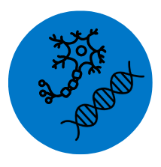*Section D:**  **MND and genetics**

This section has brief information about MND symptoms, treatment and causes. See [www.mndassociation.org](http://www.mndassociation.org) for more information.

**Motor neuron disease**

Up to 5,000 adults are living with MND in the UK at any one time. Around 1 in 300 people (0.3% or 3 in 1000 people) develop MND in their lifetime. MND is diagnosed by neurologists. Neurologists are doctors who know about health problems linked to the brain and nervous system. MND is also called amyotrophic lateral sclerosis (ALS).

MND is a disease affecting the nerves (or neurons) in a person’s brain and spinal cord. Motor neurons are nerves that control how a person’s muscles move. MND damages these nerves, stopping them from controlling how the muscles move. People experience symptoms linked to the muscles that stop working, including muscle weakness, wasting and loss of movement; muscle tightness and cramps; problems with breathing and tiredness; difficulties with speech, swallowing and saliva. Some people’s thinking, behaviour and emotions change. Some people get a form of dementia called frontotemporal dementia (FTD) [4].

***Managing MND***

Health and social care professionals help people manage their symptoms and keep as good a quality of life as possible. MND professionals include neurologists, physiotherapists, specialist nurses and occupational therapists. There is no cure for MND. MND is a life-shortening illness. Treatment and care plans help people with MND stay independent for as long as possible, and comfortable at the end of their lives [2, 3].

***Causes of MND***

MND is thought to be caused by a mix of factors linked to person’s environment, lifestyle, and genes. For about 80-90% of people with MND, the exact cause of their disease is not known. In about 10-20% of people with MND, their disease is caused by a gene change [4, 9, 10]. Not everyone with a gene change linked to MND will develop symptoms [11]. The next section has information about gene changes linked to MND.

## ***Section D logo*Genetic or inherited forms of MND**

When MND is caused by a gene change, and passed down in families, this is known as inherited, familial or genetic MND [15]. When a disease is inherited, it means a gene change linked to the disease is passed down from a parent to their child. Each person has two sets of genes. One set of genes is passed down from each parent.

Scientists have found many gene changes linked to MND. They keep looking for more gene changes in their research. The most common gene changes in inherited MND are *C9orf72*, *SOD1*, *FUS* and *TARDBP*.

**Table summarising the most common gene changes in inherited MND** [9, 10]

|  |  |  |  |  |
| --- | --- | --- | --- | --- |
|  | ***SOD1*** | ***TARDBP*** | ***FUS*** | ***C9orf72*** |
| Year Found | 1993 | 2008 | 2009 | 2011 |
| Chance of the gene change passing from parent to child | 50% (1 in 2). There are rare gene changes where the chance is less. | 50% (1 in 2). There are rare gene changes where the chance is less. | 50% (1 in 2). There are rare gene changes where the chance is less. | 50% (1 in 2). |
| Chance of a person with the gene change getting MND | Not everyone with a gene change will get symptoms in their lifetime. | Not everyone with a gene change will get symptoms in their lifetime. | Not everyone with a gene change will get symptoms in their lifetime. | Not everyone with a gene change will get symptoms in their lifetime. |
| Age people develop symptoms | Adults of any age can develop symptoms. | Adults of any age can develop symptoms. | Adults of any age can develop symptoms. Some *FUS* gene changes can cause MND from teenage years. | Adults of any age can develop symptoms. |
| Link to other neurological health problems | SOD1 gene changes do not usually cause other health problems | *TARDBP* can cause FTD and other neurological symptoms. | *FUS* gene changes can cause FTD and other neurological symptoms. | *C9orf72* gene changes can cause FTD and other neurological and psychiatric symptoms. |
| Clinical trials and treatment | Tofersen can slow down the progress of the disease [16]. Ask a neurologist for further information. | No genetically targeted treatments have been found to work. See Section F for information on clinical trials. | No genetically targeted treatments have been found to work. See Section F for information on clinical trials. | No genetically targeted treatments have been found to work. See Section F for information on clinical trials. |

******People with MND experience the disease in different ways. Even when two relatives have the same gene change, they can get different symptoms, at different ages, and their disease progresses at different rates.

***MND and frontotemporal dementia (FTD)***

Certain gene changes linked to MND are also linked to other neurological health problems. For example, *C9orf72* is linked to MND and to frontotemporal dementia (FTD) [9, 10]. People with this gene change may get MND, FTD or both diseases. Some people may not get either disease. It is not possible to say which disease or symptoms people will get.

***How is MND passed down in families***

The chance of a gene change linked to MND being passed down from a parent to a child is usually 50% (1 in 2 chance). This is because most gene changes linked to MND are passed down in what is called a dominant inheritance pattern [9, 10]. Only one parent needs to have the gene change for their child to have a 50% chance of getting it.

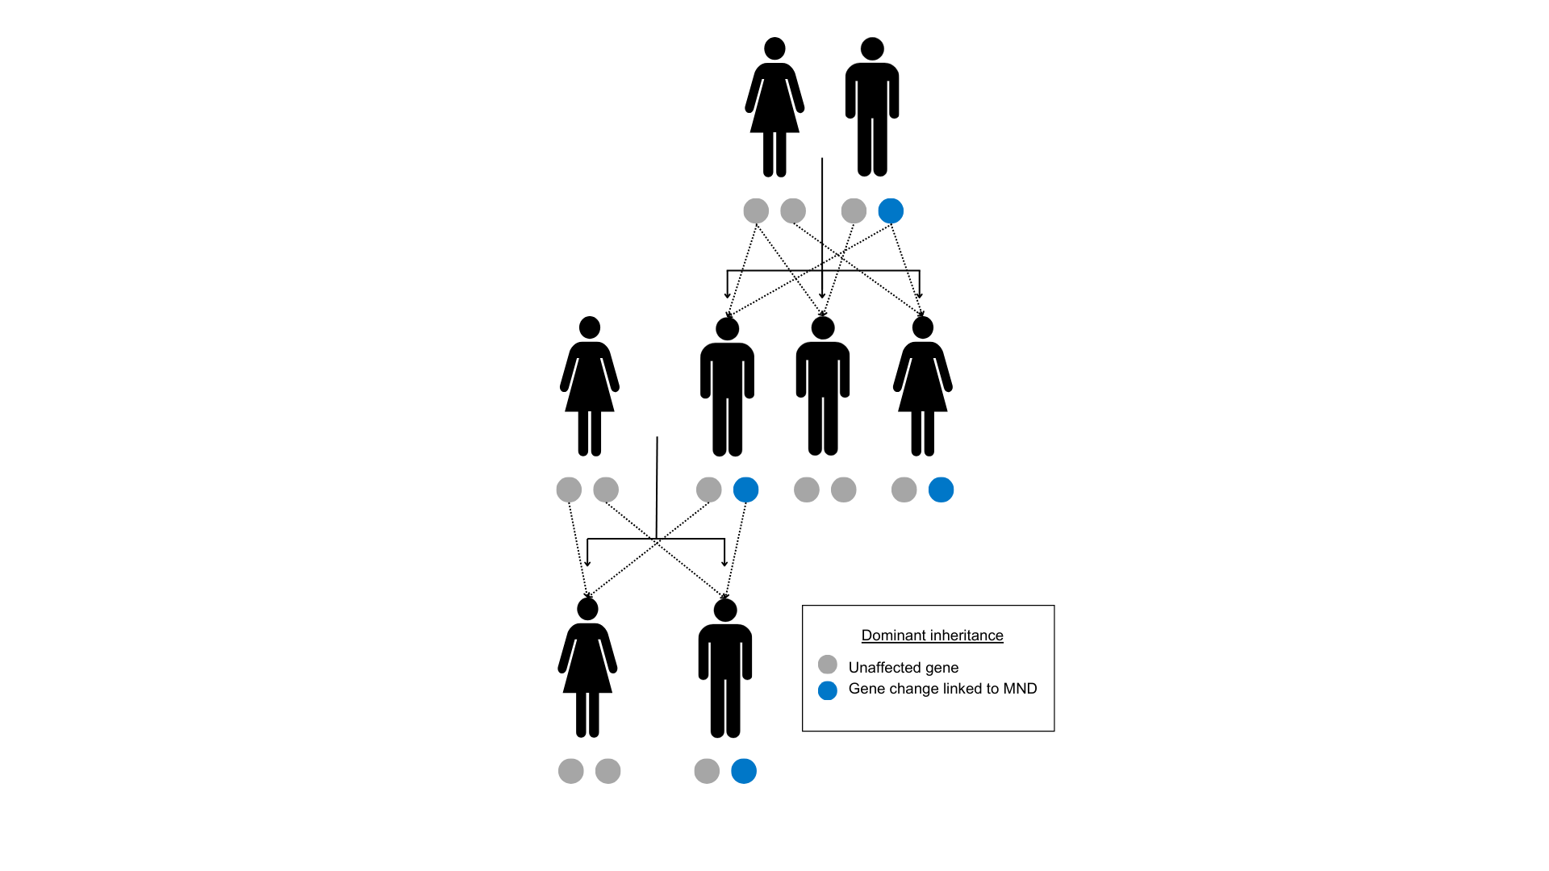

Some people have a rare gene change linked to MND that is passed down from a parent to their child in a different pattern. This recessive inheritance pattern means any children are less likely to inherit the gene change [9, 10].

******The chance of each child inheriting a gene change from their parents is the same for each pregnancy. The chance is the same if the baby is a girl or a boy, or looks like their parent or not.

***What is the chance of developing symptoms for people with a gene change***

Not everyone who has a gene change linked to MND will develop symptoms of the disease in their lifetime. Scientists and doctors cannot explain why some people with a gene change develop MND, and others do not. They have found that the chance of this happening may be higher or lower depending on the gene change [11]. They cannot predict the chance for any one person. The term penetrance is used by scientists to describe the chance a person with a gene change linked to a disease will get that disease.

***What is the chance of finding a gene change through genetic testing***

Genetic testing cannot always find a gene change in a person with MND even if they have a family history of MND. This is because scientists have not found all the gene changes linked to MND yet. There may still be an inherited form of MND in the family. If no gene change is found in a person with MND, their family members cannot have predictive genetic testing or reproductive genetic testing.

Some people with MND who have a gene change linked to their disease do not have a known family history of MND. Scientists are more likely to find a gene change linked to MND in people with a family history, than in people without a family history [9, 20, 21].

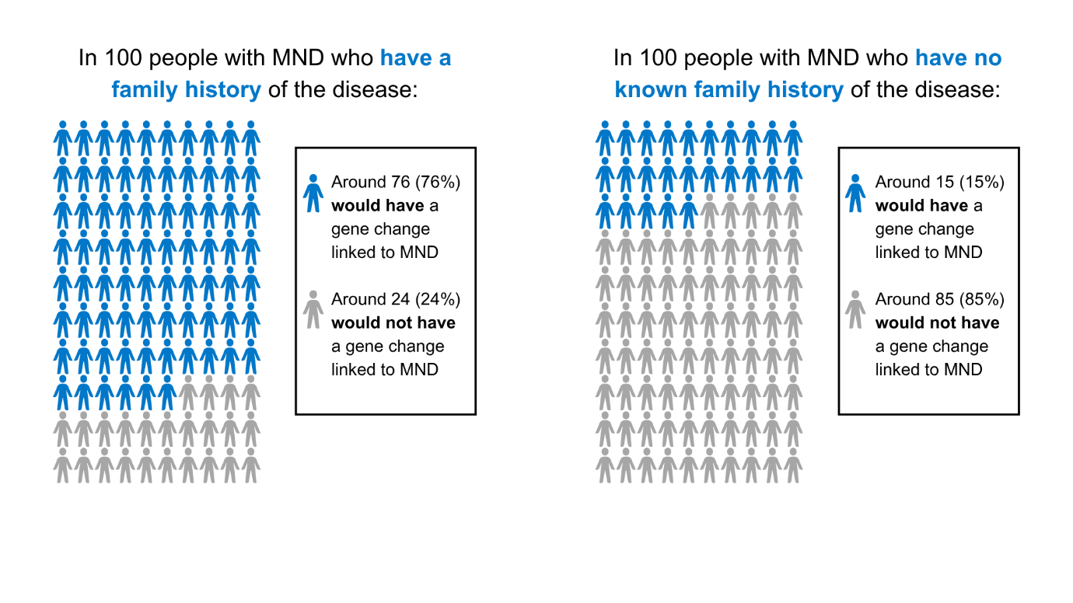

Some people with MND who have a gene change do not know of any relatives who had MND before them. There are many reasons why people may not know of other family ******members with MND. Family members may have been diagnosed with a different illness such as FTD, or they may have had the gene change but not got MND symptoms in their lifetime.

***Use this space to jot down your thoughts or questions. You can use these notes when talking with your family and healthcare team.***



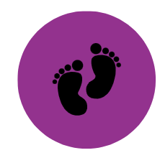**Section E: Options for having a family in MND**

This section has information about options people with MND and their family members may think about when planning to have children. Many people decide to have a family without having genetic testing. Others decide to have genetic testing before making plans for a family. This section may be relevant for you if you are thinking about having children.

**What options are available depends on each person’s situation. Options people might think about when having children include:**

* Have children without any extra testing (accept the chance of having a child with the gene change linked to MND)
* Adoption
* Egg or sperm donation
* Surrogacy
* Pre-implantation genetic testing (PGT)
* Prenatal testing (PNT)

**People have different views on these options based on their personal goals, values and what feels right for their family** [8, 22, 23]**. Views may change over time.**

**Map of reproductive options for people with MND in the family**

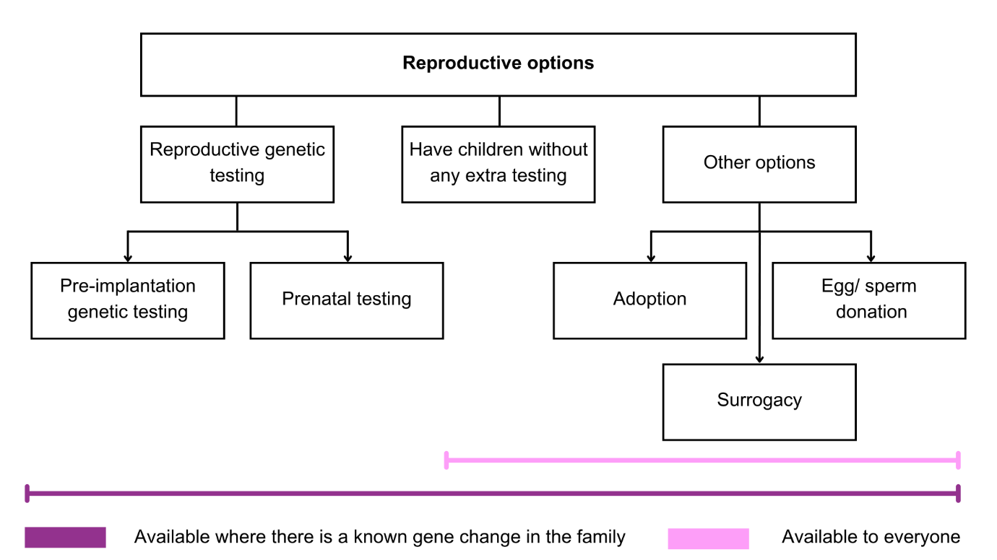

This rest of this section gives information about pre-implantation genetic testing (PGT) and prenatal testing (PNT). These options may be offered to people who know the gene change linked to their MND, and their close family members. People with MND and family members can check with their healthcare team about what options are available to them.

**Reproductive genetic testing options**

Pre-implantation genetic testing and prenatal testing are types of reproductive genetic testing. People may be interested in finding out about these options if they wish to have a biological child without the chance of passing on the gene change linked to MND.

Some people find making these reproductive genetic testing decisions difficult. These options can have physical, emotional and financial consequences for couples, and their families. The two reproductive genetic testing options are:

***Pre-implantation genetic testing (PGT)*** is a type of testing that involves usingin vitro fertilisation (IVF). The egg is fertilised with the sperm in a laboratory, to make an embryo. Embryos are then tested to see if they have the gene change linked to MND. Only embryos without the gene change are put into the womb, with the hope they will continue into a pregnancy. PGT is sometimes called pre-implantation genetic diagnosis (PGD). There are guidelines that say who can have PGT paid for on the NHS.

***Prenatal testing (PNT)*** is a type of testing that can be used during pregnancy. From 11 weeks of pregnancy, tests can be carried out to see if the fetus (developing baby) has the gene change linked to MND. These tests are usually carried out through one of two methods, called chorionic villus sampling (CVS) or amniocentesis. The PNT result can either be positive, the fetus does have the gene change; or negative, the fetus does not have the gene change. If the test result is positive for the gene change, the couple consider ending the pregnancy. There is a small chance that the methods used in PNT can cause the loss of the pregnancy (miscarriage). PNT is sometimes called prenatal diagnosis (PND).

People making reproductive genetic testing decisions can talk with a member of their healthcare team about their options. Some services have genetic counsellors to talk about reproductive genetic testing decisions and help people think through what is important to them. Section F includes links to more information on options for having a family.

***Use this space to jot down your thoughts or questions. You can use these notes when talking with your family and healthcare team.***



**Section F: Further information - glossary, resources, references and project details**

**Glossary**

Below is a list of words that you might hear when talking about MND and genetic testing, together with their meaning.

|  |  |
| --- | --- |
| **Term** | **Description of term** |
| Clinical trial | A clinical trial is a type of research study which looks to see whether treatments or interventions are safe and effective (how well they work). Often, this is studied by comparing people who have been given the treatment or intervention with people who have not been given it. |
| Dominant inheritance | Autosomal dominant inheritance means it takes just one copy of a gene change for a person to develop the disease. Each child of a person with this kind of gene change has a 50% (1 in 2) chance of getting it from their parent. |
| Frontotemporal dementia | Frontotemporal dementia (FTD) is the name for a group of health problems which can cause changes to personality and behaviour, problems with language, and difficulties with concentration, planning and organisation. FTD is sometimes called frontal lobe dementia or Pick’s disease. |
| Gene | Genes are instructions which tell our bodies how to work and grow. They control or influence traits such as eye colour and height. Genes are passed down from parents to their child when they become pregnant. |
| Gene change | Sometimes changes or mistakes are made in our genetic code, which can change how a gene works. Some of these gene changes can cause health problems. A gene change that can cause a health problem is sometimes called a pathogenic gene variant or gene mutation. |
| Genetically targeted treatment | Genetically targeted treatments are drugs that target a particular gene change to try and make the gene work as it should do, or stop it working in a harmful way. Tofersen is a genetically targeted treatment. |
| Genetic counselling | Genetic counselling helps people to understand their risk of having a genetic condition, what it could mean for themselves and their family, and their options, including around genetic testing. It is carried out by a specialist in genetic conditions (a genetic counsellor or a genetics consultant) and usually involves having several appointments over a period of time. People can ask their GP for a referral. |
| Genetic counsellor  Section F logo | Genetic counsellors are trained health professionals who support families with genetic health problems to understand and think about what this means for them. They can support people to think through their options, including around genetic testing. |
| Genome | A genome is a person’s entire genetic code. It contains all their genes as well as the other sections in between which are less well understood. |
| Inheritance | Inheritance is the way genetic information is passed down through generations, from a parent to their child. |
| Inherited motor neuron disease | Sometimes, MND is caused by a change in a gene that is passed down in families. This is known as inherited, familial or genetic MND. |
| Motor neuron disease | Motor neuron disease (MND) is a disease that stops signals reaching the muscles, which causes the muscles to stop working. Some people also experience changes to their thinking, behaviour and emotions. MND is also called amyotrophic lateral sclerosis (ALS). |
| Neurological | Neurological diseases are health problems that affect the brain, spinal cord and nerves, known as the nervous system. |
| Neurologist | A neurologist is a doctor who has done specialist training in neurological diseases. Neurologists are trained to diagnose and treat people with neurological symptoms. |
| Penetrance | Penetrance means the chance that a person with a gene change will get the disease. If a gene change is not fully penetrant not everyone who has the gene change will get symptoms of the disease in their lifetime. |
| Predictive genetic testing | Predictive genetic testing is a type of genetic testing. It can be used by people who have a family member with a gene change linked to MND. Having a predictive test tells them if they have the same gene change, or not. People with the gene change have a higher chance of developing MND in the future. |
| Pre-implantation genetic testing | Pre-implantation genetic testing (PGT) uses a process of in vitro fertilisation (IVF). Embryos are made in a laboratory and genetically tested to see if they have the gene change linked to the health problem. Only embryos that do not have the gene change can continue to a pregnancy. |
| Prenatal testing | Prenatal testing (PNT) involves genetically testing a pregnancy to see if the fetus (developing baby) carries the gene change linked to the health problem that has been found in the family. |
| Recessive inheritance | Autosomal recessive inheritance means it takes two copies of a gene change for a person to get the disease, one passed down from each parent. Where both parents have a recessive gene change, each of their children have a 25% (1 in 4) chance of getting two copies. |
| Reproductive genetic testing | Reproductive genetic testing is a type of genetic testing that can be done either before pregnancy (pre-implantation genetic testing) or during pregnancy (prenatal testing). This can be used by some people who have a gene change linked to MND and want to have children without passing it on. It can sometimes be used by family members with a chance of having a gene change. |
| Secondary findings | A secondary finding is a type of test result that may be found through whole genome sequencing. It means a gene change linked to another health problem has been found. This is not related to why the person got MND, but may have other consequences for the person and their family. Sometimes, this is called an ‘incidental’, ‘additional’ or ‘reportable’ finding. |
| Tofersen | Tofersen is a genetically targeted treatment designed to treat MND caused by changes in the *SOD1* gene. It has been shown to slow down the progress of the disease. |
| Variant of Uncertain Significance | A Variant of Uncertain Significance (VUS) is a type of test result that may be found through whole genome sequencing. This means scientists and doctors are not sure if the gene change is the cause of the MND or not. People may be offered more tests. |
| Whole genome sequencing | Whole genome sequencing (WGS) is a type of genetic testing which looks at the person's whole genome - all their genetic code rather than just specific genes. WGS may be offered to people with MND in England. |



**Information and support resources**

Below are some resources and links which you can use to find more information about the topics raised in this decision aid.

***Key organisations offering information and support***

* MND Association: <https://www.mndassociation.org/> including section ‘Inherited MND’: <https://www.mndassociation.org/about-mnd/mnd-explained/inherited-mnd>
* MND Scotland: <https://mndscotland.org.uk/>
* MND Association Northern Ireland: <https://www.mndani.com/>
* FTD talk: <https://www.ftdtalk.org/>
* Rare Dementia Support: <https://www.raredementiasupport.org/>
* Video resource on experiences of inherited MND: <https://hexi.ox.ac.uk/Familial-MND/overview>
* Genetic Alliance: <https://geneticalliance.org.uk/>
* Your Genome: <https://www.yourgenome.org/>
* Your clinical team

***Research and clinical trial information***

* MND Association: <https://www.mndassociation.org/research/research> (UK based)
* UK MND Clinical Studies Group: <https://www.mndcsg.org.uk/home> (UK based)
* UK MND Research Institute: <https://ukmndri.org/> (UK based)
* ALS.org: <https://www.als.org/research/als-research-topics> (US based)
* NEALS (Northeast ALS Consortium): <https://neals.org/> (US based)

***Genetic testing and insurance***

* Genetic Alliance UK: https://geneticalliance.org.uk/insurance-and-genetic-conditions-faqs/
* MND Connect: https://www.mndassociation.org/support-and-information/our-services/mnd-connect
* The Association of British Insurers: <https://www.abi.org.uk/data-and-resources/tools-and-resources/genetics/>

***Family planning and reproductive genetic testing***

* MND Association information sheet B3 ‘Inherited MND: Options when starting a family’, available at: [www.mndassociation.org](http://www.mndassociation.org)
* Human Fertilisation & Embryology Authority, information on pre-implantation genetic testing for monogenic disorders (PGT-M): <https://www.hfea.gov.uk/treatments/embryo-testing-and-treatments-for-disease>

**References**

The references below show the evidence used to develop this decision aid. Please get in touch using the contact details provided if you cannot access any of the references.

[1] NHS England. National Genomic Test Directory [Internet]. England.nhs.uk. 2018. Available from: https://www.england.nhs.uk/publication/national-genomic-test-directories/

[2] National Institute for Health and Care Excellence (NICE). Motor neurone disease: assessment and management. NICE guideline [NG42]. [Internet]. Nice.org.uk. 2019. Available from: https://www.nice.org.uk/guidance/ng42

[3] Van Damme P, Al‐Chalabi A, Andersen PM, Chiò A, Couratier P, De Carvalho M, Hardiman O, Kuźma‐Kozakiewicz M, Ludolph A, McDermott CJ, Mora JS. European Academy of Neurology (EAN) guideline on the management of amyotrophic lateral sclerosis in collaboration with European Reference Network for Neuromuscular Diseases (ERN EURO‐NMD). European journal of neurology. 2024 Jun;31(6):e16264.

[4] Talbot K. Motor neuron disease: the bare essentials. Practical neurology. 2009 Oct 1;9(5):303-9.

[5] Roggenbuck J, Eubank BH, Wright J, Harms MB, Kolb SJ, ALS Genetic Testing and Counseling Guidelines Expert Panel, Ajroud‐Driss S, Arcila Londono X, Bauer G, Benatar M, Bedlack R. Evidence‐based consensus guidelines for ALS genetic testing and counseling. Annals of clinical and translational neurology. 2023 Nov;10(11):2074-91.

[6] Howard J, Bekker HL, McDermott CJ, McNeill A. Exploring the needs and preferences of people with amyotrophic lateral sclerosis (ALS) when making genomic testing decisions: an interview study. Amyotrophic Lateral Sclerosis and Frontotemporal Degeneration. 2025 Feb 27:1-8.

[7] Crook A, Jacobs C, Newton‐John T, McEwen A. Genetic counseling and diagnostic genetic testing for familial amyotrophic lateral sclerosis and/or frontotemporal dementia: A qualitative study of client experiences. Journal of genetic counseling. 2022 Oct;31(5):1206-18.

[8] Crook A, Jacobs C, Newton-John T, Richardson E, McEwen A. Patient and relative experiences and decision-making about genetic testing and counseling for familial ALS and FTD: a systematic scoping review. Alzheimer Disease & Associated Disorders. 2021 Oct 1;35(4):374-85.

[9] Akçimen F, Lopez ER, Landers JE, Nath A, Chiò A, Chia R, Traynor BJ. Amyotrophic lateral sclerosis: translating genetic discoveries into therapies. Nature Reviews Genetics. 2023 Sep;24(9):642-58.

[10] Goutman SA, Hardiman O, Al-Chalabi A, Chió A, Savelieff MG, Kiernan MC, Feldman EL. Emerging insights into the complex genetics and pathophysiology of amyotrophic lateral sclerosis. The Lancet Neurology. 2022 May 1;21(5):465-79.

[11] Douglas AG, Baralle D. Reduced penetrance of gene variants causing amyotrophic lateral sclerosis. Journal of Medical Genetics. 2024 Mar 1;61(3):294-7.

[12] NHS East Genomics. Whole genome sequencing for a rare disease, information for patients and family members. Genomic Medicine Service. [Internet]. Eastgenomics.nhs.uk. Available from: https://www.eastgenomics.nhs.uk/for-patients-and-carers/considering-whole-genome-sequencing/

[13] Lacoangeli A, Dilliott AA, Al Khleifat A, Andersen PM, Başak NA, Cooper-Knock J, Corcia P, Couratier P, deCarvalho M, Drory VE, Glass JD. Oligogenic structure of amyotrophic lateral sclerosis has genetic testing, counselling and therapeutic implications. Journal of Neurology, Neurosurgery & Psychiatry. 2025 Feb 13.

[14] Crook A, Williams K, Adams L, Blair I, Rowe DB. Predictive genetic testing for amyotrophic lateral sclerosis and frontotemporal dementia: genetic counselling considerations. Amyotrophic lateral sclerosis and frontotemporal degeneration. 2017 Oct 2;18(7-8):475-85.

[15] Howard J, Chaouch A, Douglas AG, MacLeod R, Roggenbuck J, McNeill A. Genetic testing for monogenic forms of motor neuron disease/amyotrophic lateral sclerosis in unaffected family members. European Journal of Human Genetics. 2024 Nov 5:1-7.

[16] Miller TM, Cudkowicz ME, Genge A, Shaw PJ, Sobue G, Bucelli RC, Chiò A, Van Damme P, Ludolph AC, Glass JD, Andrews JA. Trial of antisense oligonucleotide tofersen for SOD1 ALS. New England Journal of Medicine. 2022 Sep 22;387(12):1099-110.

[17] Witteman HO, Ndjaboue R, Vaisson G, Dansokho SC, Arnold B, Bridges JF, Comeau S, Fagerlin A, Gavaruzzi T, Marcoux M, Pieterse A. Clarifying values: an updated and expanded systematic review and meta-analysis. Medical Decision Making. 2021 Oct;41(7):801-20.

[18] Ottawa Personal Decision Guide © 2015 O’connor, Stacey, Jacobsen. Ottawa Hospital Research Institute & University of Ottawa, Canada

[19] Ferron Parayre A, Labrecque M, Rousseau M, Turcotte S, Légaré F. Validation of SURE, a four-item clinical checklist for detecting decisional conflict in patients. Medical Decision Making. 2014 Jan;34(1):54-62.

[20] Salmon K, Kiernan MC, Kim SH, Andersen PM, Chio A, Van den Berg LH, Van Damme P, Al-Chalabi A, Lillo P, Andrews JA, Genge A. The importance of offering early genetic testing in everyone with amyotrophic lateral sclerosis. Brain. 2022 Apr 1;145(4):1207-10.

[21] Shepheard SR, Parker MD, Cooper-Knock J, Verber NS, Tuddenham L, Heath P, Beauchamp N, Place E, Sollars ES, Turner MR, Malaspina A. Value of systematic genetic screening of patients with amyotrophic lateral sclerosis. Journal of Neurology, Neurosurgery & Psychiatry. 2021 May 1;92(5):510-8.

[22] Howard J, Forrest Keenan K, Mazanderani F, Turner MR, Locock L. Experiences of predictive genetic testing in inherited motor neuron disease: Findings from a qualitative interview study. Journal of genetic counseling. 2025 Feb;34(1):e1904.

[23] Howard J, Mazanderani F, Keenan KF, Turner MR, Locock L. Fluctuating salience in those living with genetic risk of motor neuron disease: A qualitative interview study. Health Expectations. 2024 Apr;27(2):e14024.

**Patient decision aid standards**

Elwyn G, O'Connor A, Stacey D, Volk R, Edwards A, Coulter A, Thomson R, Barratt A, Barry M, Bernstein S, Butow P. Developing a quality criteria framework for patient decision aids: online international Delphi consensus process. Bmj. 2006 Aug 24;333(7565):417.

Stacey D, Volk RJ, IPDAS Evidence Update Leads (Hilary Bekker, Karina Dahl Steffensen, Tammy C. Hoffmann, Kirsten McCaffery, Rachel Thompson, Richard Thomson, Lyndal Trevena, Trudy van der Weijden, and Holly Witteman). The International patient decision aid standards (IPDAS) collaboration: evidence update 2.0. Medical Decision Making. 2021 Oct;41(7):729-33.



Stacey D, Lewis KB, Smith M, Carley M, Volk RJ, Douglas EE, Pacheco-Brousseau L, Finderup J, Gunderson J, Barry M, Bennette CL, Bravo P, Dahl Steffensen K, Gogovor A, Graham ID, Kelly SE, Legare F, Sondergaard H, Thomson R, Trenaman L, Trevena L. [Decision aids for people facing health treatment or screening decisions.](https://www.cochranelibrary.com/cdsr/doi/10.1002/14651858.CD001431.pub6/full) Cochrane database of systematic reviews. 2024.

**Project details**

***Development of this decision aid***

This decision aid was developed by a study team from the Universities of Sheffield and Leeds. This decision aid is based on our research into how people make decisions about genetic testing for MND. Our study steering group included family members with lived experience of MND, health professionals, and people from the MND Association. We wish to thank everyone who has advised our study and taken part in our research.

***The study team***

Alisdair McNeill - Consultant in Clinical Genetics at Sheffield Children’s Hospital and Senior Clinical Lecturer in Neurogenetics at University of Sheffield

Hilary Bekker - Professor of Medical Decision Making at University of Leeds

Chris McDermott - Consultant Neurologist at Sheffield Teaching Hospitals and Professor of Translational Neurology at University of Sheffield

Jade Howard - Postdoctoral Researcher at University of Sheffield

***The steering group***

Jennie Starkey - Expert by experience

Christine Hoskin - Expert by experience

Calum Kendal - Expert by experience

Jennifer Beford - Head of Partnerships, Education and Information at the MND Association

Angela Genge - Executive Director of the Clinical Research Unit and Director of the ALS

Global Centre of Excellence, Montreal Neurological Institute; Chief medical officer, QurAlis

Kristiana Salmon - MND research & independent consultant; previously, academic research focused on genetic counselling and testing access and clinical practice in Canada

Martin Turner - Professor of Clinical Neurology & Neuroscience at Oxford University and Consultant Neurologist at the John Radcliffe Hospital

***Project funding***

This research was funded by the Motor Neurone Disease Association (2022-2025).

***Studies carried out to inform the decision aid***

Howard J, Bekker HL, McDermott CJ, McNeill A. A report of resources used by clinicians in the UK to support motor neuron disease genomic testing. Amyotrophic Lateral Sclerosis and Frontotemporal Degeneration. 2024 Apr 2;25(3-4):410-2.

Howard J, Bekker HL, McDermott CJ, McNeill A. Survey of service needs to embed genome sequencing for motor neuron disease in neurology in the English National Health Service. Journal of Medical Genetics. 2024 Jul 1;61(7):661-5.

Howard J, Bekker HL, McDermott CJ, McNeill A. Exploring the needs and preferences of people with amyotrophic lateral sclerosis (ALS) when making genomic testing decisions: an interview study. Amyotrophic Lateral Sclerosis and Frontotemporal Degeneration. 2025 Feb 27:1-8.

Howard J, Bekker HL, McDermott CJ, McNeill A. Predictive genetic testing in amyotrophic lateral sclerosis (ALS): experiences of decision-making within UK genetic counselling services [under review].

***Referencing the decision aid***

Howard J, McNeill A, McDermott CJ, Bekker HL. Genetic testing and motor neuron disease: A decision aid. 2025. Available from: https://mymndgenetest.shef.ac.uk

***Conflicts of interest***

The authors have no conflicts of interest, financial or otherwise. This decision aid was developed from a research grant funded by the MND Association after external peer review. The funders, study team, steering committee and their employers do not stand to benefit from the decisions people make after reading this booklet.

***Contact***

Alisdair McNeill, Sheffield Institute for Translational Neuroscience, University of Sheffield.

✉️ [a.mcneill@sheffield.ac.uk](mailto:a.mcneill@sheffield.ac.uk) 